Pax Christi
Peace Sunday
20 January 2019

Fraternity, the
foundation and
pathway to peace
Pope Francis,
World Peace Message 2014

Fraternity, the
foundation and
pathway to peace
Pope Francis,
World Peace Message 2014

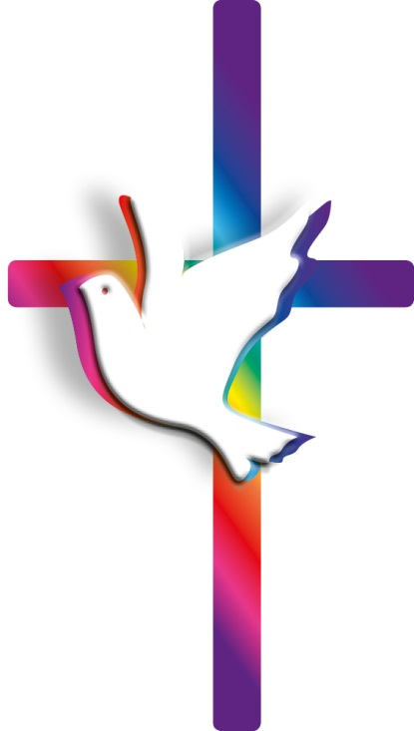
Fraternity, the
foundation and
pathway to peace
Pope Francis,
World Peace Message 2014

‘Good politics serves peace’
Pope Francis - World Peace Message 2019

Promoted by Pax Christi with the support of the International Affairs Department, Catholic Bishops’ Conference, England and Wales
Ideas to help the celebration of World Peace Day
in your parish

Before Peace Sunday

If you have a Pax Christi parish contact or Justice and Peace group in the parish, enlist them in helping to prepare for the day. Invite them, and those who prepare liturgy/children’s programmes, to use the materials in this booklet. These resources can help you prepare a Mass, vigil, or holy hour for peace.

The week before Peace Sunday (Sunday 13 January) put a notice in your parish newsletter/website to remind people of the day and theme. Make a link to the Pax Christi Peace Sunday webpage.
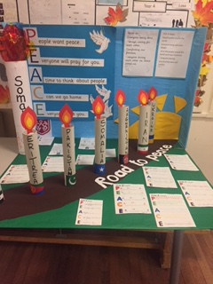
Arrange for the new prayer card to be given out on Peace Sunday.

The Week of Prayer for Christian Unity from 18 - 25 January takes its theme from Deuteronomy 16:18-20, ‘Justice, and only justice, you shall pursue…’ Resources for 2019, prepared by Christians from Indonesia, can be found here https://ctbi.org.uk/week-of-prayer-for-christian-unity-resources

Peace Sunday could be the beginning of a year of reflection and action for peace. Ideas in this booklet and other resources from Pax Christi can support your own plans and initiatives.

Your help is essential to us. Please consider taking a collection to support the work of Pax Christi.

All written materials may be reproduced with acknowledgement. They are also available on the Peace Sunday page of our website www.paxchristi.org.uk.
© Fr Rob Esdaile for liturgy and scripture reflections.
The 52nd World Day for Peace, will be observed in England and Wales on
20 January, 2019, the 2nd Sunday of Ordinary Time (Year C). The readings for the Sunday Eucharist are Isaiah 62.1-5; Ps 96 (95) 1-3, 7-10 (resp. V.3);
1 Cor 12.4-11; Jn 2.1-11.

Introduction to the Liturgy

The Bishops of England and Wales invite us to make today a day of prayer for peace and to reflect on the theme Pope Francis has chosen for the annual World Day of Peace with the challenging title: ‘Good politics serves peace’.

The Gospel for this Sunday gives us a most wonderful basis for reflection on our calling to work together for peace (and to get involved in the political process, too, in order to seek that goal). We meet Jesus, his mother and his disciples at the Wedding Feast of Cana. He shares in our human joys – the joys of family, the joys of human love and the pledge of fidelity that unites one heart to another. But he also shares in our sorrows – Mary’s cry: ‘They have no wine’; the realisation that our own resources are run dry, our bonds of love prove fragile, our promises are all too easily betrayed.

Suggested Penitential Act

Let us turn to Christ, the Prince of Peace, and ask his healing of our hearts, of our relationships and of the political life of our nation.

Lord Jesus, Master of the Wedding Feast. Lord, have mercy.

Christ Jesus, you who invite us to share in your joy. Christ, have mercy.

Lord Jesus, who turns the water of our own little efforts into the new wine of the Kingdom. Lord, have mercy.

Introduction to the Readings

First Reading (Isaiah 62.1-5)
The Prophet Isaiah promises transformation to the battered city of Zion: ‘You shall be called by a new name’. Not abandonment but delight, not mourning but a wedding feast – these are her destiny, for God delights in his Creation and wills the peace of Jerusalem, the happiness of all.

Second Reading (1 Cor 12.4-11)
What do we have in common as Christians, for all our diversity? It is the gift of the Spirit, says St Paul, which makes the gifts of each and every one of us fruitful and allows those gifts to be used for the good of all. It is a breath-taking and hope-filled vision. But, as the Second Vatican Council taught 54 years ago, that same Spirit is at work in the life of all people of good will. Violence is not an inevitability. Peace is possible, if only we will listen to the Spirit.

Gospel (Jn 2.1-11)
Who are the most important people in the extraordinary events of the Wedding Feast of Cana? Our reflex is to say: Jesus or Mary. But we should also acknowledge the servants who, despite all appearances of futility, dare to go about their work, ‘doing whatever he tells them’ and taking what they know to be only water to the steward. It is through the ordinary day-to-day efforts of ordinary people, through the faithful witness of Christians to the values of the Kingdom and the possibility of peace, that the miraculous happens and the new wine of the Kingdom is made available in abundance to the guests at the Wedding Feast.

Homily Notes – First Reflection

It is not uncommon for preachers to presume that today’s Gospel of the Wedding Feast is self-evidently ‘good news’ and of obvious relevance to their hearers. We fail to notice that for many people marriage has become optional (if not objectionable). Nearly half of our children are born out of wedlock and 1.78 million dependent children live in single-parent households. The level of relationship-failure in our culture is (literally) painfully high. And, on top of that, the wedding industry does its best to turn the wedding itself into something fundamentally individualistic and – dare I say it? – selfish: ‘your special day’, often preceded by other expensive self-indulgences in the form of hen- and stag- nights (or weekends) and followed by – you guessed it – ‘the holiday of a lifetime’.

How can this text speak to our troubled experience of family life and of a divided society today? How can we discover afresh the Good news of this Gospel story? And what can it teach us about ‘Peace Sunday’ (since that is the theme today, chosen by the Church in England and Wales as a focus for our prayer and action)?
It helps to go back to the text and its context and to read it carefully. Jesus has not gone to celebrate the marriage. He’s just a guest. We can’t be sure how Jewish marriages were celebrated in First Century Palestine – but what is clear is that this was not simply the marriage of two individuals. It was the cementing of new links within the clan. The loss of face caused by providing insufficient wine would have had the potential to cause a feud that might last for generations. The comment by the Mother of Jesus – ‘They have no wine’ – is much more urgent in tone than it might be in the unlikely event of present-day wedding guests drinking the bar dry.

Yet it’s in this dialogue between Mary and her Son that the contemporary relevance of this dramatic incident breaks through, despite the enormous differences between now and then. ‘They have no wine.’ Somewhere along the line we have to come to that place where we admit that we have run out of resources, reached the end of our own strength and capacity. Mature faith only becomes possible with this painful realisation. The deeper love of a couple can probably only fully awaken through such a crisis, too, when they have to decide to build a future together despite everything as well as because of everything. That’s what can save a marriage from the impoverished vision of the wedding industry with the ‘wedding list’ that seeks to furnish the ideal home, rather than to build a life-giving love.

Jesus’ reply to his mother also has a contemporary ring: ‘My hour has not yet come’. Of course, in the Fourth Gospel that sentence carries an enormous amount of theological baggage. For John, ‘The Hour’ means the moment of Christ’s death and his glorification. But for Jesus then and for us now the time is never right. Facing up to human need is always inconvenient, inopportune. Standing up for truth, for justice, for hope and peace is always untimely.
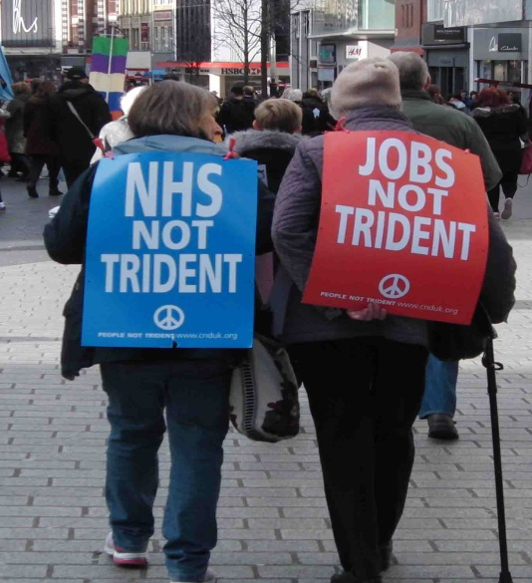

But if not now, when? When will we tackle the personal tragedies and social disasters brought about by climate change – which always affects the poor most deeply and in turn leads to conflict over scarce resources and large-scale displacements of populations? When will we name for what it is the criminal waste of both money and human ingenuity on the development of weapons (including Trident, our very own Weapon of Mass Destruction, and its multi-billion-pound replacement)? When will we face up to the toxic effects of the arms trade around the world, an arms trade so strongly protected in our own country’s industrial base?

The time is not right. The time is never right. So Mary ignores his objections. ‘Do whatever he tells you,’ she says. She entrusts the present crisis to the labours of the servants, who do not really grasp how they can make any difference but do as they are asked anyway, filling the stone jars with water and then taking a jugful to the steward.

‘Do whatever he tells you!’ A new world is possible – possible for nations caught up in war and preparations for war; possible for societies divided by social strife and populist politics; possible for families in crisis and for couples who have no wine, no joy, no strength left for the life-journey they must make together despite their paucity of resources. Peace is possible – but only if we dare to hope and dare to be caught up in the hour that has not quite come yet; only if we, who recognise our thirst – ‘They have no wine’ – will follow Mary’s call and ‘Do whatever he tells you’.

Homily Notes - Second Reflection

‘About Zion I will not be silent, about Jerusalem I will not grow weary,’ says the Prophet. It’s not true of course. We have all long since learnt to avert our gaze from the reality of the strip of territory at the east end of the Mediterranean which we piously call ‘The Holy Land’ and which goes from bad to worse; the possibilities of peaceful coexistence and mutual respect chipped away year after year by the ‘facts on the ground’ – separation barriers, illegal settlements, the economic squeeze which hits the remnants of the Palestinian Christian Church perhaps more harshly than any other group. We have grown silent, too, about so many other situations in the Middle East and beyond – many of them countries with our western fingerprints all over them. We accept that that’s just the way things are, without asking how our country’s foreign policy might have caused the mess.

Both internal repression and international conflict combine with climate change to cause the flow of refugees around the globe. Yet again we avert our gaze, hoping that no bodies may be washed up on the beaches of Mediterranean resorts while we’re in town, and allowing other economic and social ills to distort our response, confusing and conflating refugees, asylum-seekers and those who come to our country to work (and who provide so much of the labour in the health service and the care sector). But can’t we do better than this denial of reality and sloppy thinking?

Isaiah sang of his love of Jerusalem at a time when the city struggled to rebuild after half a century of exile in Babylon. The city he loved knew all too well what ‘forsaken’ meant and what ‘abandoned’ looked like. And yet he dreamed another way was possible. ‘You shall be called my delight and your land “The Wedded”.’ Integrity would be restored. A time of fruitfulness and peace, a time of plenty after want, this too would come. That was his dream – a dream he dared to share and militate for. Will we not do the same? If we don’t voice our hopes and our vision, others will – and the result may be far from the vision of the Wedding Feast of God’s Kingdom which Jesus preached and anticipated in the miracle at Cana.

Today the Church in England and Wales celebrates ‘Peace Sunday’, reflecting on the theme chosen by Pope Francis for the ‘World Day of Peace’. This year he reminds that ‘Good politics serves peace’. That has an immediate relevance not only at the global level – think of Trump’s USA and the ‘shouty’ populism that dominates political debate in so many countries – but also in our own uneasy situation in the UK as we approach Brexit. We are a nation divided (52% against 48% according to the 2016 Referendum, whatever the figures might be now). Here too, healthy politics must be about seeking reconciliation and a healing of the wounds caused by that knife-edge decision. So how might we go about that?

It has to begin with ourselves, with the refusal to dismiss those who disagree with us as ‘fools’, unworthy of respect. We need to learn again how to listen to each other – and to listen with special attention to those who feel in some way ignored or looked down on. We need the self-discipline not to resort to slogans. And before we try to change the opinions of others we have to be willing to have our own hearts and minds changed.
“Let us pray together that the language of love and dialogue may always prevail over the language of conflict.”

Pope Francis, prayer intention for November 2018

That only becomes possible when we root our reflection in prayer, a listening to the heart and an opening of ourselves to the Gospel. For it is from the Gospel that we need to derive a vision of where we want to get to. The prophet Isaiah’s hope was to ‘rebuild Zion’. Can we put our own hope into words? What sort of society do we seek? What sort of future do we wish for our children?

Of course, we won’t all agree on the details, but from our ethical tradition (what we call ‘Catholic Social Teaching’) we can identify some building-blocks. The themes of solidarity (reaching out to others because they are our brothers and sisters) and subsidiarity (empowering decisions at the local level); the inalienable value of the individual and the pursuit together of the Common Good (which always keeps in view the weakest and the most vulnerable and never sacrifices others for our own convenience): these are the materials with which we can reimagine our whole way of living.
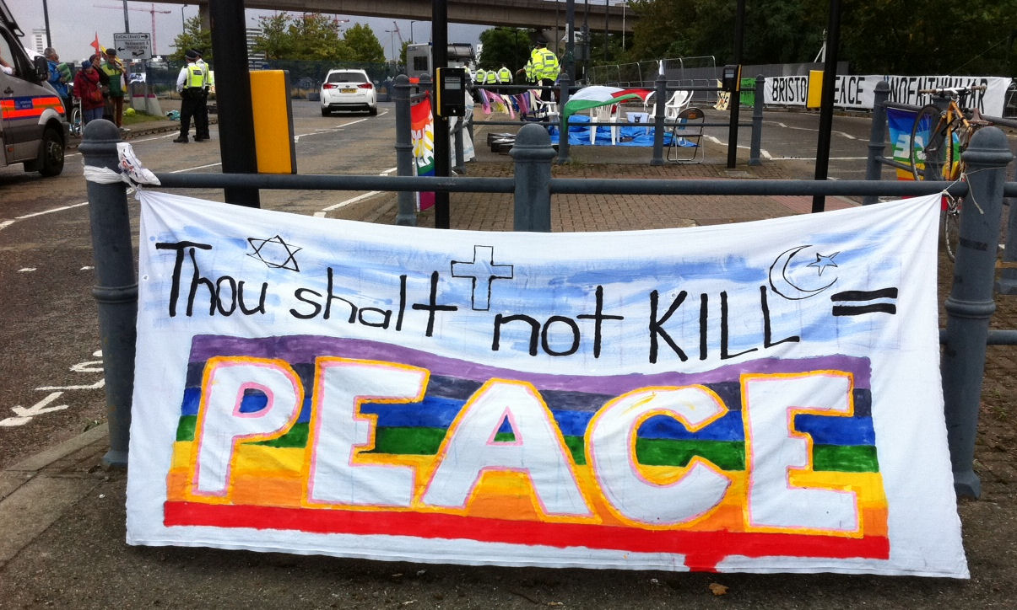
Once we start to put our vision into words and once that vision excites us, awakening in us both possibilities which we had not seen before and an awareness of injustices which had not troubled us before, then we realise that mere words are not enough. ‘Good politics serves peace’, says Pope Francis. And good politics needs good people. We cannot simply shrug our shoulders and say that ‘politics isn’t for us’. We need to get involved – and to pray for those who devote their energies to the political process, whether in political parties or in particular campaigning groups. We need humbly to speak our truth – and our truth is the beautiful and joyous truth that every human being is our brother or our sister and that the earth is our Mother. All belong and all are needed if we are to rebuild the human city and make it truly a city of peace, not of war.

Prayers of the Faithful – some suggestions

Priest: St Paul reminds us: There is a variety of gifts but always the same Spirit, the Spirit who brings communion, peace and hope. In the power of the Spirit let us pray for ourselves, the Church and the world.

We pray for the Church: together may we witness to the Gospel of peace, creating a community where all can find reconciliation, and strife is replaced by understanding.
Lord in your mercy: HEAR OUR PRAYER.

Let us ask God’s blessing on the married and on all who have pledged their love – that when they feel that ‘they have no wine’ and their strength is exhausted, the Lord may rekindle their love and, in every trial, may comfort them.
Lord in your mercy: HEAR OUR PRAYER.

Let us pray for all who serve us in political life at every level – in local councils and national parties, in parliament and government and in campaign groups. May they serve us honestly and always seek the Common Good, with a special care for the last and the least in our world.
Lord in your mercy: HEAR OUR PRAYER.

We pray for the peace of Jerusalem and for all who dwell in the Holy Land. May the rights of all be respected and may the communities learn the art of dialogue which alone can penetrate barriers and remove fear.
Lord in your mercy: HEAR OUR PRAYER.

We pray today for reconciliation in every place where there is conflict; for peace where there is fighting. We remember today especially [name a situation of oppression or violence in the news at the moment ...]
Lord in your mercy: HEAR OUR PRAYER.

We ask God’s blessing on all who work for peace and justice, on all who will not be silent in the face of injustice or human hurt; on all who take risks for peace. We ask God’s blessing today especially on the work of the international Catholic Peace Movement, Pax Christi.
Lord in your mercy: HEAR OUR PRAYER.

Let us commend to God’s mercy all who are unwell (especially ……………………), that they might be restored to health; and all who have died (especially…………...). May they be gathered, with people of every race and language and way of life, into the joy of God’s Kingdom.
Lord in your mercy: HEAR OUR PRAYER.

In a moment of silence, let us place before the Lord our own thirst for peace.

Final Prayer: Pour out into our hearts and into our world, O Lord, the Dove of Peace, the Spirit of Reconciliation. Hear our prayers and lead us all together to the Wedding Feast of your eternal Kingdom through Jesus Christ our Lord. Amen.

Prayer & reflection

Lord God of peace, hear our prayer!
We have tried so many times and over so many years to resolve our conflicts by our own powers and by the force of our arms.
How many moments of hostility and darkness have we experienced;
how much blood has been shed; how many lives have been shattered;
how many hopes have been buried… But our efforts have been in vain.
Now, Lord, come to our aid!
Grant us peace, teach us peace; guide our steps in the way of peace. Open our eyes and our hearts, and give us the courage to say:
"Never again war!" "With war everything is lost".
Instill in our hearts the courage to take concrete steps to achieve peace. Amen.
Pope Francis, 2014
“Peace involves work; it is not about staying calm and doing nothing. No!
True peace means working so that everyone has a solution to the problems, to the needs, that they have in their land, in their homeland, in their family, in their society.”

Pope Francis, audience with children of the Peace Factory, 2015

For reconciliation

Loving God,
you have reconciled us in Christ Jesus
and have given us the ministry of reconciliation.
We pray for all those from whom we are estranged.
Bring healing to strained or broken relationships.
Forgive us for the times we have wronged others,
whether by ignorance, neglect, or intention.
Grant us the courage and the grace to seek their forgiveness
and opportunity to make amends.
Where others have wronged us,
grant us a gracious spirit,
that we might forgive
even as we have been forgiven in Jesus Christ. Amen.

https://www.rca.org/resources/prayers-peace-and-justice
Personal prayer of nonviolence
O God, of Mercy and Compassion, open our hearts to your grace.
We ask You to:
Bless us with courage to embrace nonviolence in our everyday lives;
Bless us with vision to seek alternatives when violence appears as the only solution;
Encourage us to look deeply at our own complicity that allows violence to continue in our own hearts and in our world;
Bless us with insight to see the roots of violence inherent in our community / society;
Bless us with the tenacity to stay committed to the struggle to shape a more peaceful, nonviolent world for all your people.
O good and gracious God, source of all life,
all creation is charged with your Divine Energy.
Grant us the strength and courage, we pray,
for a radical transformation of own lives and a
deeper realization of your Kin-dom among us. Amen.
Sisters of Mercy USA (slightly adapted)
A prayer for conversion to Gospel Nonviolence
Blessed are the peacemakers, you said, O Lord, for they shall be called children of God.
We ask you, Lord, to forgive us for the times we’ve caused division or misunderstanding in our communities. We know that communion is not achieved through coercion, but through constant conversion.
We ask for the grace to not speak ill, not criticize, not to be sowers of strife, so that peace can reign in our hearts. From this conversion of the heart, Lord, lead us to a version in actions. First in our hearts, then in our world incarnate the power of gospel nonviolence.
Give us the imagination to overcome all forms of violence with creative nonviolence. Revive in our church’s theology of peace the nonviolent message of Jesus, that once again our churches may be centres of learning for nonviolence and just peace, centres of conversion from violence to peace, and from loneliness to joy. Amen.

Catholic Nonviolence Initiative, https://nonviolencejustpeace.net/
First they came

In Germany, first they came for the Communists, and I didn’t speak out because I was not a Communist.
Then they came for the Jews, and I didn’t speak out because I was not a Jew.
Then they came for the trade unionists, and I didn’t speak out because I was not a trade unionist.
Then they came for the Catholics, and I didn’t speak out because I was a Protestant.
Then they came for me - and there was no one left to speak out for me.
Martin Niemöller, Lutheran Pastor imprisoned by the Nazis

Peacemaking round the year

In London, Westminster Cathedral Primary School created an art-work for Holy Apostles parish for Peace Sunday 2018. Each class made a 3D paper candle, writing on it the name of a country which refugees have had to leave. These were presented on a 3D display of a road with the words ROAD to PEACE along it and a picture of a DOVE.

Helga Galloway from St Gregory’s parish, Barnet, organised a stall in her church on Peace Sunday and reported: ‘I was pleased that our pastoral assistant used the children’s activity cards in the children’s liturgy group and with the communion preparation group. Cards were also given to other children and their parents. More than 100 Pax Christi membership leaflets were handed out’.
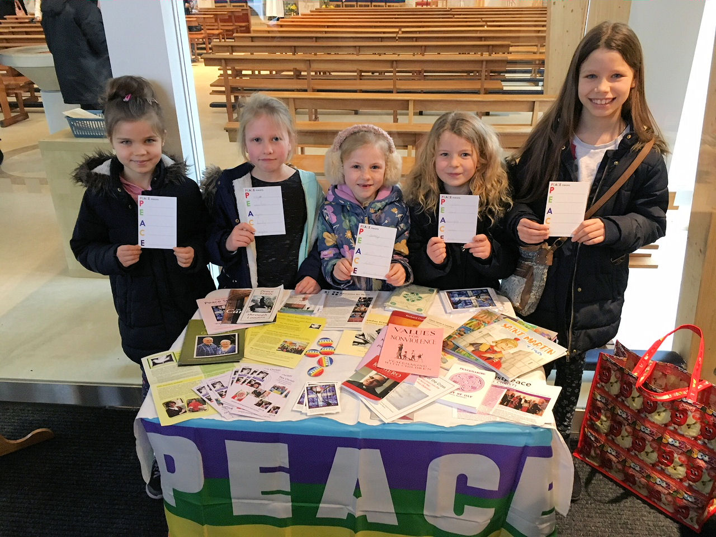

For International Women’s Day on 8 March Pax Christi invited women around the world to thank Pope Francis for his leadership on peace, nonviolence and disarmament and to share a vision of peace with him. Postcards and messages read: ‘Dear Pope Francis: as a woman who wants peace, I am grateful for your leadership in affirming the gospel call to nonviolence and just peace and for your constant appeal for nuclear disarmament and an end to the arms trade’.
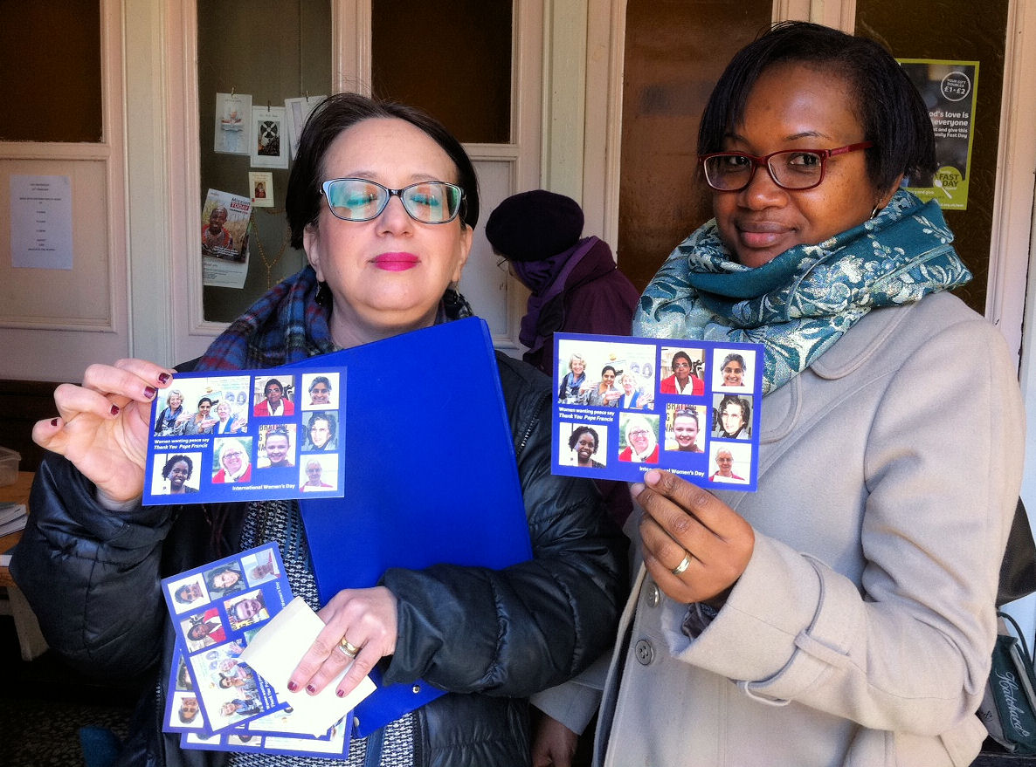

Faith in Action Day was celebrated by 60 Year Ten students (representing half of the High Schools of the Northampton Diocese) who gathered with Bishop Peter Doyle at St Paul’s, Milton Keynes. The day, organised by St Paul’s, Pax Christi, and the Northampton Youth Ministry Office, began with a chance for students to grill Bishop Peter on issues as varied as prayer, how he puts his faith into action, and the role of women in the Church.
Student Tracy Bempong said ‘I felt like it was a great, fun experience’ while Eva Ukeleghe, also from St Paul’s, said ‘I enjoyed learning and experiencing new facts about faith with new schools. I would recommend doing it’. Jennifer Rowlands, a teacher from St Paul’s, said ‘It was fantastic to see so many young people from across the diocese coming together to share their faith and to learn from one another’.
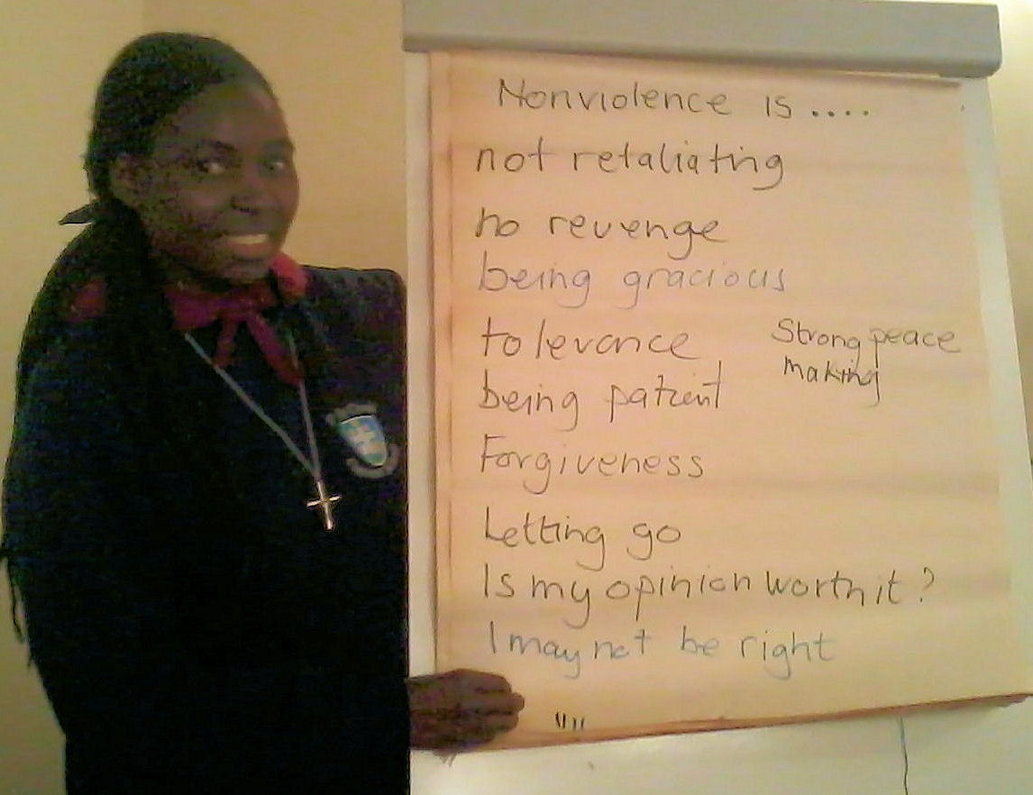
Sisters of the Holy Cross dedicated a day to the study and practice of nonviolence. With Pat Gaffney of Pax Christi they explored the meaning of active nonviolence and reflected on their own first-hand experiences of using nonviolent approaches to solving problems.

Arms trade workshops were led at Taizé, France, by Pax Christi activists Henrietta Cullinan and Nick Cooper, and Nora Ziegler from the London Catholic Worker. The workshops entitled ‘No Faith in War: Christians challenge the arms trade’ were offered at a summer gathering of over 2,000 young adults from all over Europe. Many questions were raised, partly because of problems with translation, and partly because the facts were mostly to do with UK and the US, but it was also the intention to stimulate discussion. Some participants flatly disagreed, some doubted the veracity of myth-busting facts, despite the citations, while others said they would like to be able to use the facts in arguments with their friends. Others puzzled over why governments, the UK government in particular, are so attached to the arms trade.
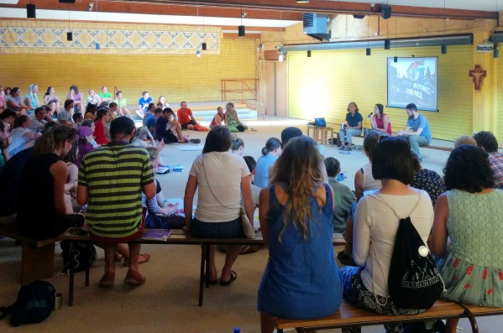
“A shout came from your young and youthful hearts, which do not tolerate injustice and cannot bow to a ‘throw-away culture’ nor give in to the globalization of indifference…
A better world can be built also as a result of your efforts, your desire to change and your generosity. Do not be afraid to listen to the Spirit who proposes bold choices; do not delay when your conscience asks you to take risks in following the Master.”

Pope Francis, invitation to young people to 2018 Synod

Crossing generations: a project for peace and justice

From Pope Francis and the Synod on Youth to a UK project, People, Faith and Justice, there is an exciting move to get people of different generations talking about how they are working for peace and justice. Peace Sunday could create an opportunity for such conversations to begin in your parish.
Pax Christi was involved in creating the People, Faith and Justice project, a very accessible and easy-to-use tool, to help start conversations in parishes, communities and groups. We discovered that the different generations
- found common ground and reciprocal appreciation and understanding. The shared space of the conversation made dialogue and challenge possible.
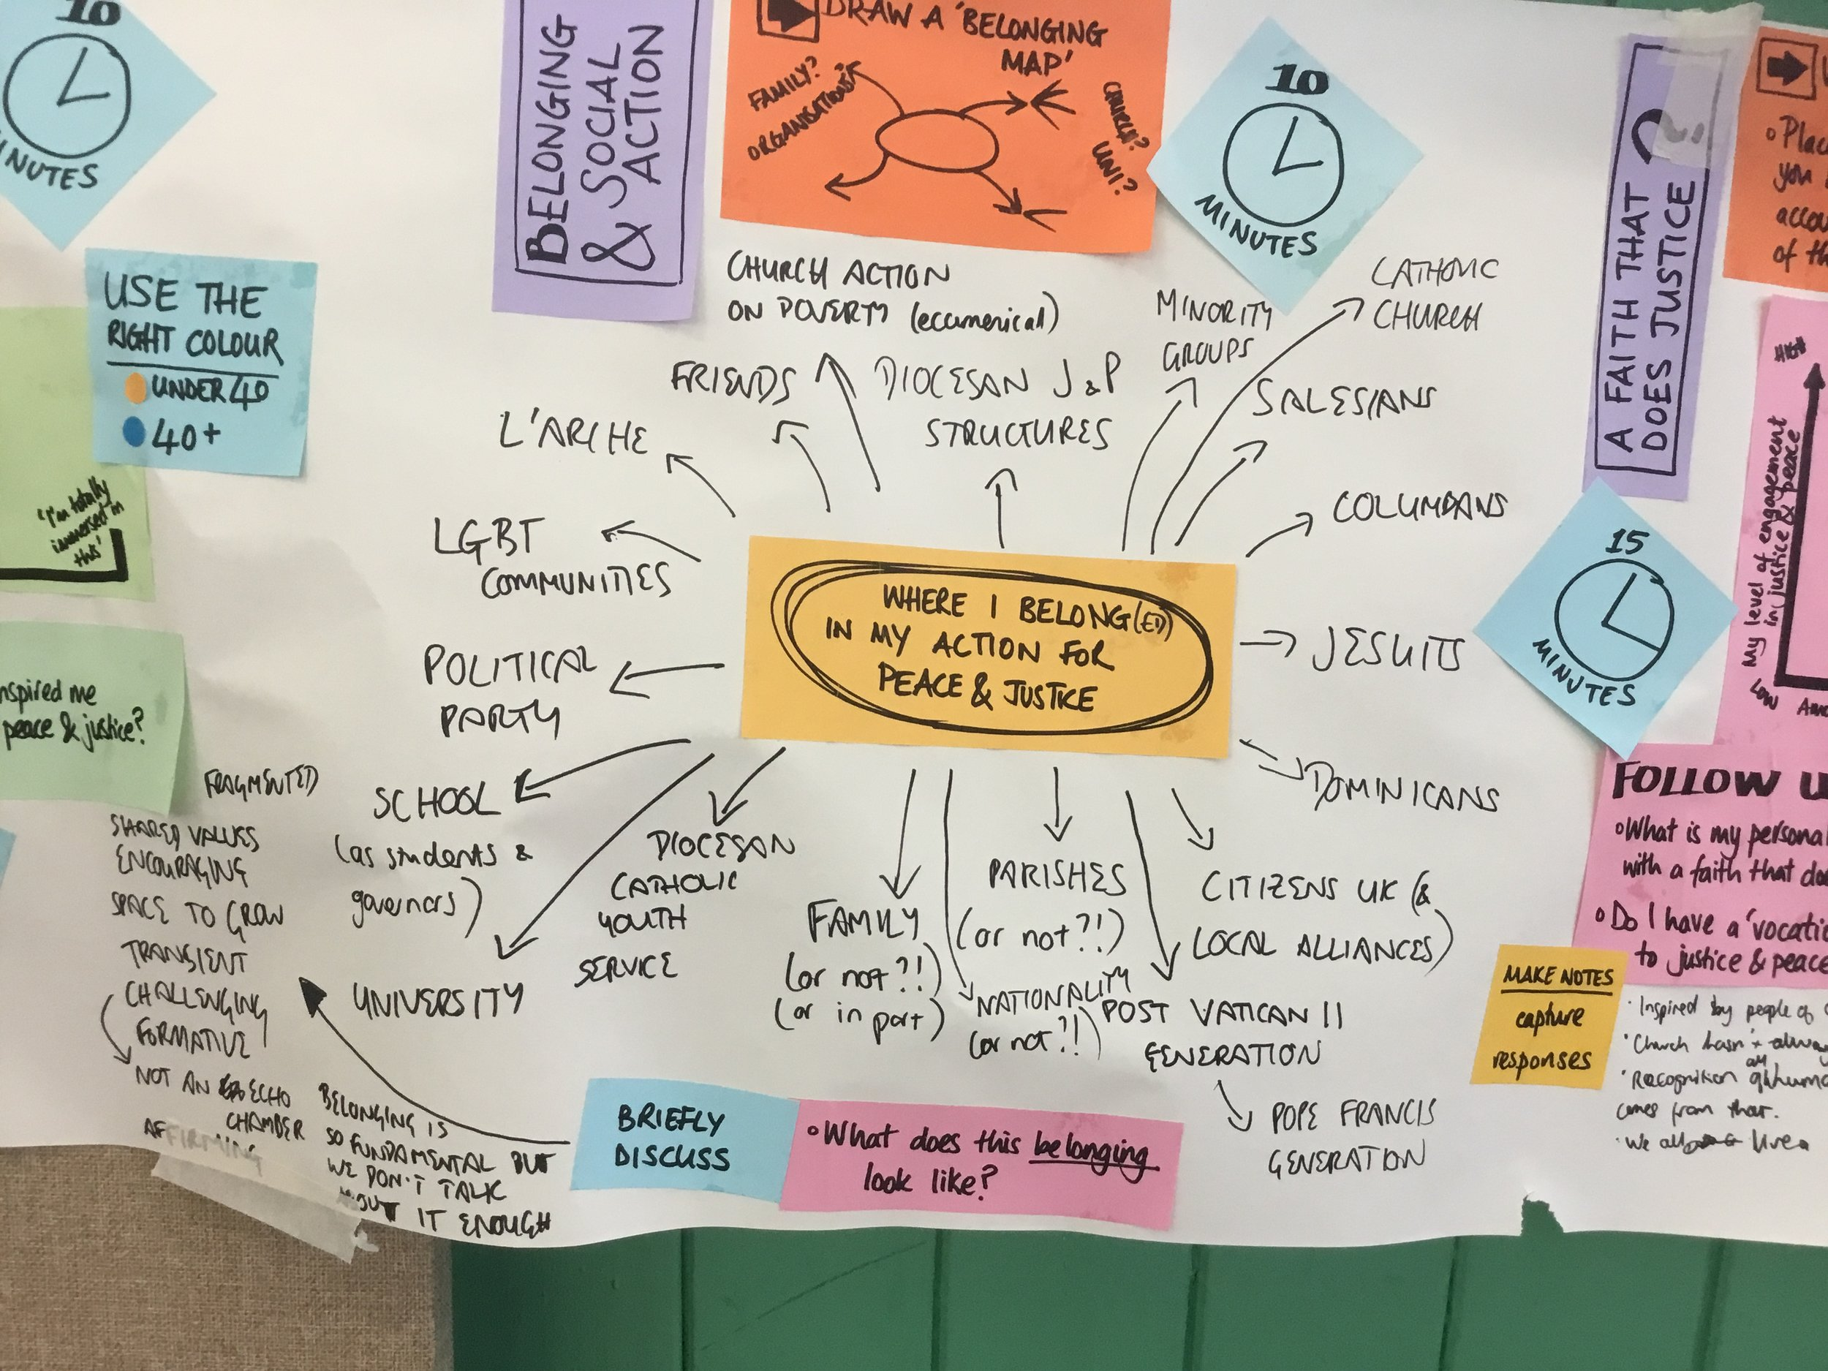
- saw that barriers can be broken, allowing ‘a view from the other side’ so that insights could be gained.
- agreed we need to find a new language, a new way of talking about justice and peace, a broader vision.
You can see a range of short videos about the project and download the easy-to-use conversation tool here https://www.peoplefaithjustice.org.uk/
Prayers and activities for children

Spreading peace

Dear God, We thank you for giving us your peace.
Help us to spread peace at home and at school by loving and caring for one another.
Help us to spread peace by listening to one another, even when we don’t agree.
Help us to spread peace by sharing our time with those who are lonely and who need a friend.
Help us to spread peace by thinking and praying for children who have no food or who are frightened and live in fear.
Let us pray every day for peace for our families, for our friends and for ourselves. Amen.
http://peace-education.org.uk/wp-content/uploads/Teach-Peace-Prayers-reflections.pdf

God, Creator of the World,
Please help us to love one another.
Make nations friendly with other nations.
Make all of us love one another like brother and sister.
Help us to do our part, to bring peace in the world and happiness to all people. Amen.
https://www.stcolumbassp.wa.edu.au/pdf/newsletters/newsletter_160915.pdf
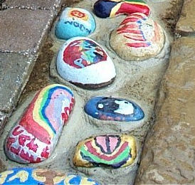

Peace pebbles
What you will need:
Some smooth pebbles large enough to write on
Coloured marker pens or chalks
A shallow bowl or tray

What to do
Buddha said ‘Better than a thousand hollow words is one word that brings peace’. What would your word or message for peace be? Choose a pebble and write or draw your message / word / prayer / symbol for peace on it.
Arrange the pebbles in the bowl or tray and bring them to the altar during Mass. Invite family and friends to look at them afterwards. If you have a parish or school peace garden you could fix the pebbles around a path or flower-bed.
Adapted from Week of Prayer for World Peace materials
Doves of peace

What you will need:
White paper, scissors, pencil or marker, orange marker or scrap of orange paper, and glue.

What to do


Place hand on white paper with fingers squeezed together and thumb extended as far as possible.



Trace around your hand.


Use a marker or pencil to draw an eye on the thumb shape.



Use an orange marker to draw on a beak, or glue a small orange triangle on for a beak.

Once you have drawn your dove you could write a message or prayer for peace on it. Bring these up to the altar during Mass, or hang them on a ‘tree of peace’ – a branch, or a poster, for everyone to see.

Adapted from Leeds Museums and Galleries Peace materials

Write a letter

Write a letter to a peacemaker. They could be someone famous or someone you know… someone from the past, or the present, or even a peacemaker of the future.
You could let them know what inspires you about their life and work, tell them about yourself and what your choices for peace are.

Article for a parish magazine:
Making Peace in Britain Today

by Fr Rob Esdaile, Parish Priest of Our Lady of Lourdes, Thames Ditton, Surrey

The theme chosen by Pope Francis for this year’s Peace Sunday (20 January 2019) seems amazingly appropriate to the situation in England and Wales as we approach Brexit’s March 29 deadline: ‘Good politics serves peace’ – and, whatever your view of the 2016 referendum, the last two years of negotiation or the current state of play, it is obvious that we need such ‘Good Politics’ right now.

People are hurting. The UK is divided. Our national conversation has broken down. Whether you’re one of the 52% or the 48%, or someone who wishes you’d voted the other way, or someone who simply wishes you’d voted; whether you’re a younger voter who blames the old or an older voter who feels misunderstood by the young, I can’t remember a time when we have felt so at odds with each other, so angry with each other. It isn’t simply that there are ‘Brexit’ and ‘Remain’ parts of the country. It is families and friendship groups which are divided.

What is the Christian response? Many believers have a strong conflict-avoiding reflex. We shrink from the ding-dong of party-politics. We seek the middle-of-the-road, remembering the beatitudes of meekness and mercy. But some of the other beatitudes are less tractable: hunger and thirst for justice, persecution in the cause of right, even the mourning for something lost which touches many at the moment. What do these ask of us in the midst of our current national disunity? Do they call us to stand up and be counted, whatever others think? What does that sixth beatitude – of purity in heart – require – a searing honesty about our take on things or keeping our counsel? And what of the seventh one – Blessed are the peacemakers?

Perhaps our first contribution as Christians really ought to be to shut up – not in a quietist, ‘keep-your-head-down-and-don’t-make-trouble’ sort of way but in prayer. Before we can help others we need to address our own jangling nerves, listen to our own hearts and hear therein a voice that speaks of peace. There is a profound prayer prayed by Dietrich Bonhoeffer during his imprisonment by the Nazis: ‘I do not understand your ways, but you know the way for me … Lord, whatever this day may bring, your name be praised’.

Then we can hope to be freed from the tyranny of our own emotions and political reflexes. Then we can begin to see that those who disagree also voted honestly and sought the good as they saw it. In sorrow rather than anger, we can begin to recognise what has been badly argued and what should never have been said (by ourselves or by others). We can reach out to rebuild shattered trust, to imagine together a better future for our country and to resist all that is merely xenophobic, prejudicial, narrow-minded or founded in fear.
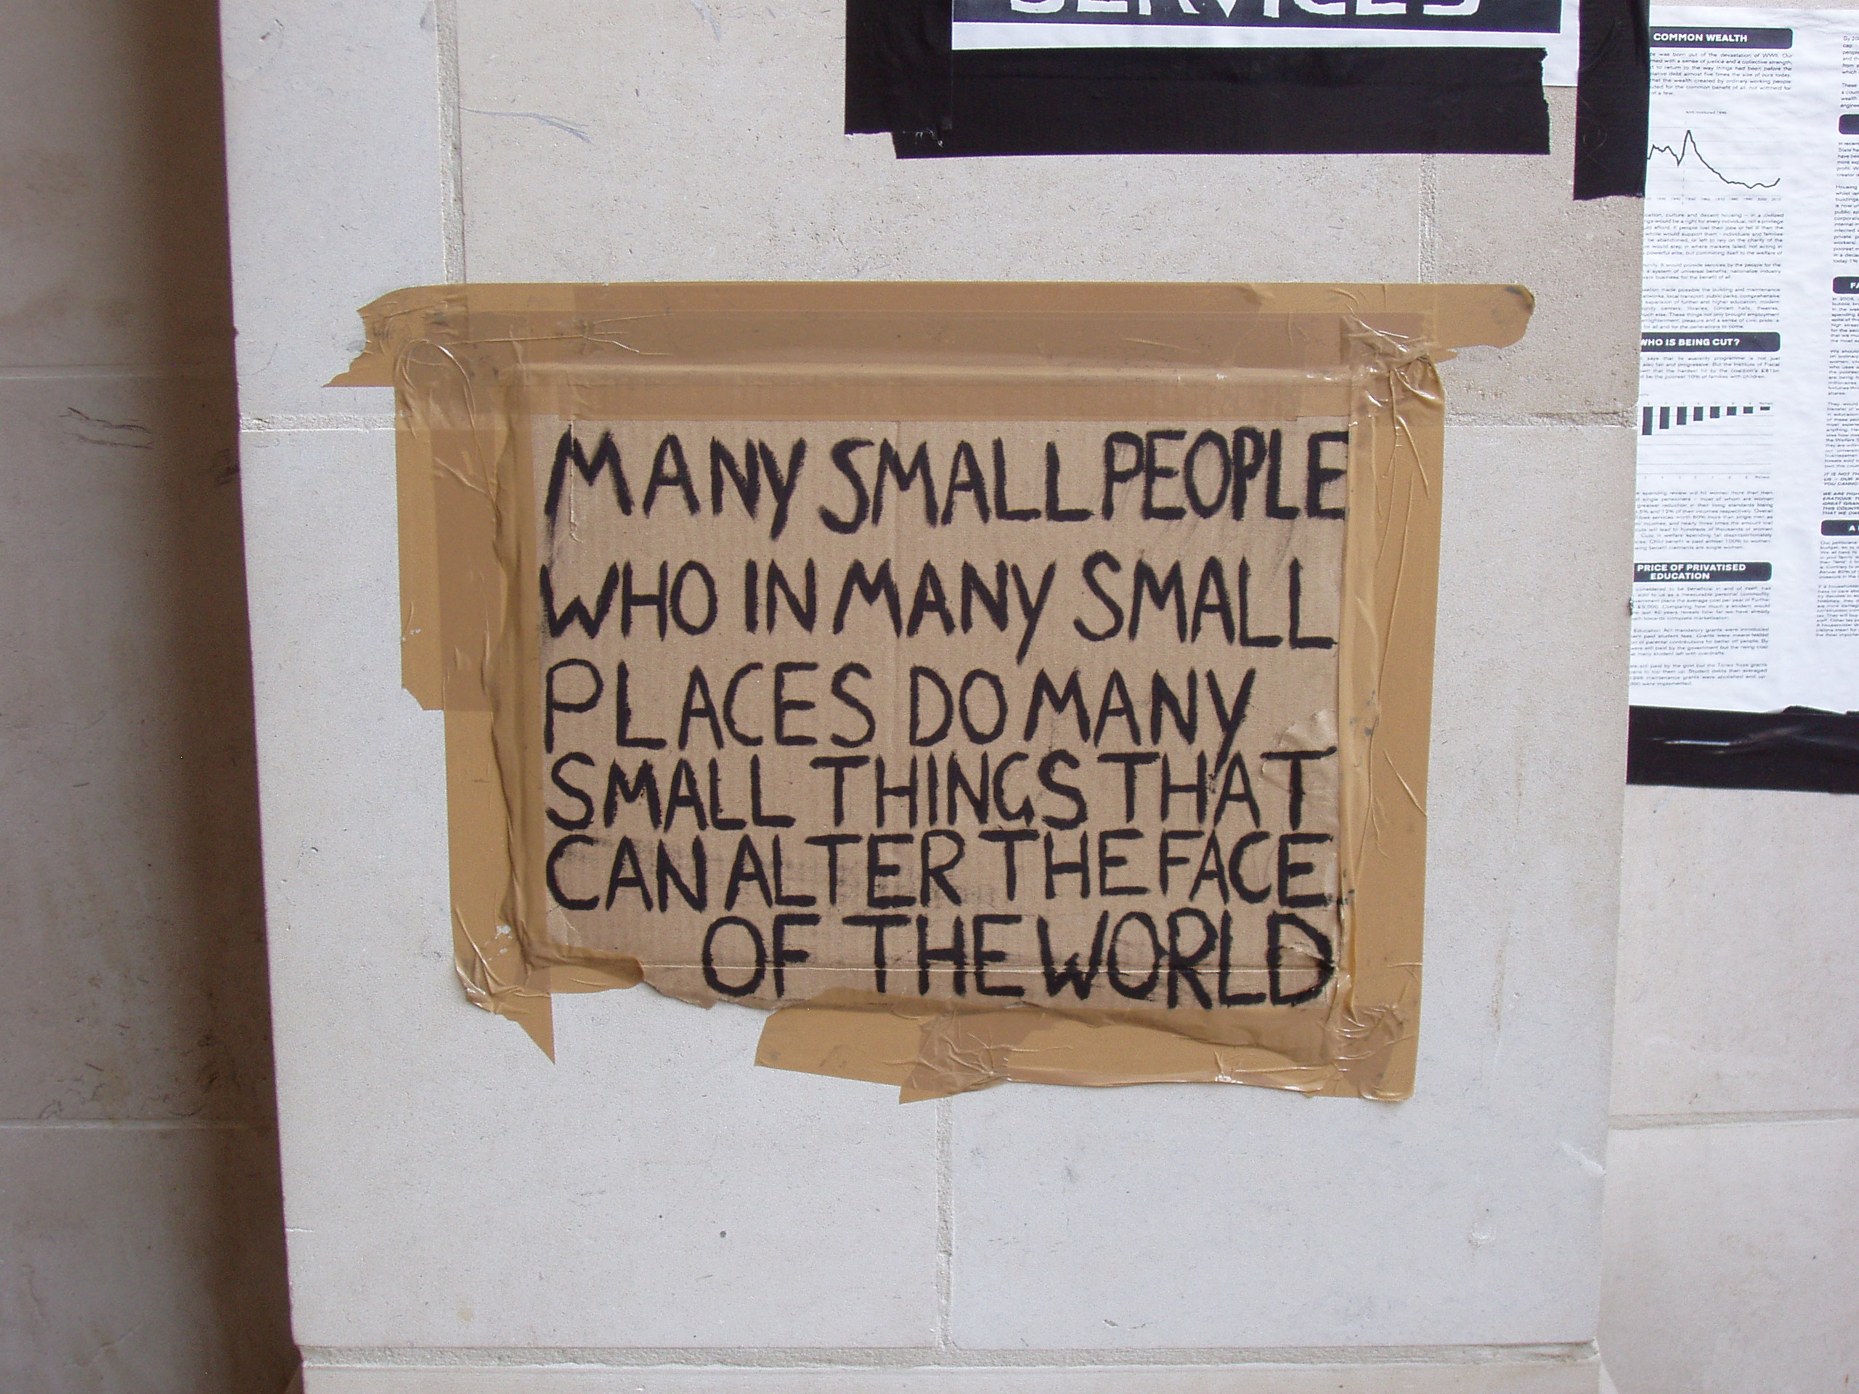

We tend to think of peace-making as something which needs to be done overseas – and surely there will be bridges to be rebuilt with our European neighbours, whatever the next few months may bring. Yet it seems that our calling may be nearer to home. As we head for March 29, 2019 (assuming anything will actually change on March 29!) our task becomes clearer – at least in the form of the questions we must ask: How can I personally reach out to people who think differently from me? How together can we rebuild community? How can we protect those left vulnerable or hurt? How can we rebuild our national conversation, our national politics and our national identity to create a space where all can thrive and fear is not the motor of debate or the deciding factor in policy decisions?

We need new peace-making skills right here at home. Fortunately the Catholic Peace Movement, Pax Christi, has a long history of promoting conflict-resolution and sharing the Gospel of Peace. To find out more about their work, or to join, contact:

Pax Christi, Christian Peace Education Centre, St Joseph's, Watford Way, London NW4 4TY.
http://paxchristi.org.uk/ e-mail: info@paxchristi.org.uk

Suggested songs

L = Laudate (Decani Music)
CH = Celebration Hymnal for Everyone with Supplement (McCrimmons)
LHON = Liturgical Hymns Old & New (Kevin Mayhew)

A touching place, John Bell - L 882 CH 115 LHON 198
For the healing of the nations, Fred Kaan – L 886 CH 179 LHON 262
Let us build a house, Marty Haugen – L 458
Jesu, Jesu, fill us with your love, (Ghana), adapted Colvin – L 241 CH 318
There is a longing in our hearts O Lord, Anne Quigley – L 941 CH 915
Tell out my soul, Timothy Dudley-Smith – L 880 CH 684 LHON 644
God is working his purpose out, A.C.Ainger – L 86 CH 217
Will you come and follow me, Bell & Maule – L 877 CH 812 LHON 740
Jesus Christ is waiting, Bell & Maule – L 889 CH 323 LHON 390
This is my will, my one command, James Quinn – L 921 CH 732 LHON 682
Christ be our Light, Bernadette Farrell – L 883 CH 891 LHON 439
The World Peace Prayer, Marty Haugen - CH 350

Useful websites

Catholic Bishops’ Conference of England & Wales:
http://www.cbcew.org.uk/CBCEW-Home/Departments/International-Affairs/

Catholic Nonviolence Initiative: www.nonviolencejustpeace.net/

Campaign Against Arms Trade: www.caat.org.uk
CAAT works to challenge UK arms sales that fuel conflicts and provoke migration around the world.
Caritas Social Action Network: www.csan.org.uk/
National Justice and Peace Network: www.justice-and-peace.org.uk
Peace encyclicals and World Peace Day messages:
tinyurl.com/encyclicals-messages

Open Democracy: www.opendemocracy.net

Resources from Pax Christi

Choosing Peace - a recent book by Pax Christi International Co-President Marie Dennis takes a deeper look at the practice of nonviolence in a violent world.

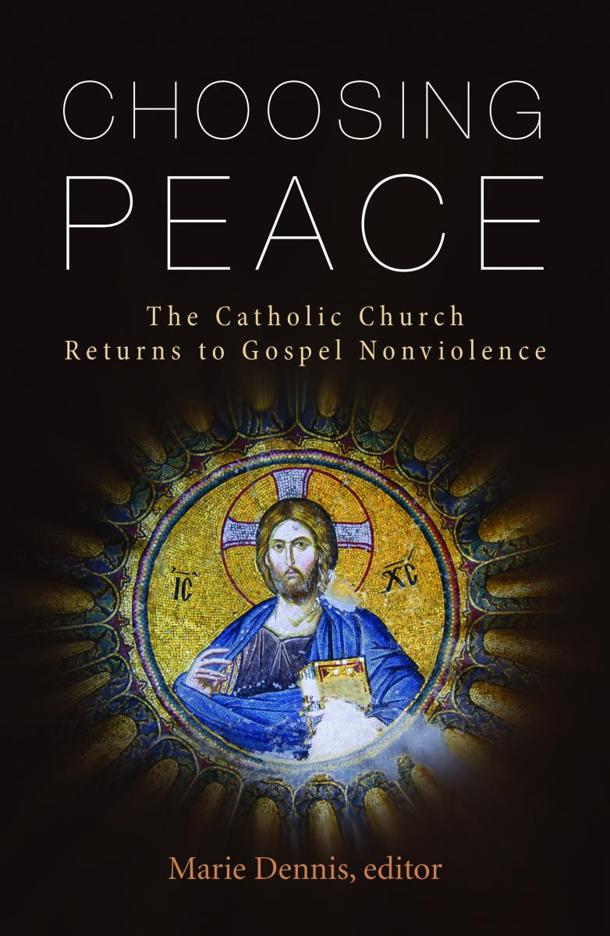

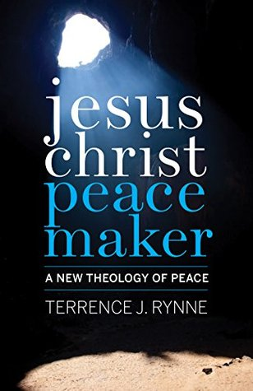
Jesus Christ Peacemaker
– a new theology of peace that renders the ‘Just War’ theory near mute by making Jesus and his teachings the cornerstone of both theory
and practice.

For children
Two excellent CTS books:
Saint Martin of Tours and
Saint Francis of Assisi.
Beautifully illustrated,
they tell the stories of these
peace saints in an accessible
and attractive way.

All available from www.paxchristi.org.uk/shop/

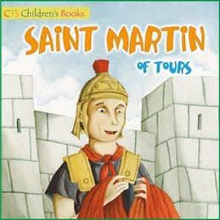
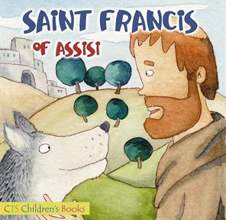


PAX CHRISTI
St Joseph’s
Watford Way
London NW4 4TY
0208 203 4884
www.paxchristi.org.uk

47.6% of births in England & Wales in 2016 were to unmarried parents (67% of those to cohabiting parents). See www.ons.gov.uk/peoplepopulationandcommunity/birthsdeathsandmarriages/livebirths/bulletins/birthsummarytablesenglandandwales/2016
https://www.ons.gov.uk/peoplepopulationandcommunity/birthsdeathsandmarriages/families/bulletins/familiesandhouseholds/2017

