DEPARTURES (OKURIBITO)
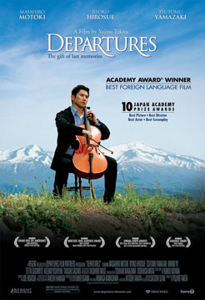
Japan, 2008, d. Yojiro Takita



A fine, often beautiful, film that can be recommended. It won the 2008 Best Foreign Film Oscar over Waltz with Bashir and The Class, strong competition.

However, you might be wondering during the first ten minutes. It begins slowly and solemnly with ceremonial and ritual for the dead. The, without warning, it becomes quite farcical and you wonder where you are. This is pre-credits. And immediately after the credits there is an orchestra playing Beethoven's Ode to Joy with a full choir. What is this film? What are the departures?

Actually, the central character of the film, the young Daigo, a cello player whose orchestra is shut down, wonders about this same question when he applies for a job on returning to his home town. He thinks he will work for a travel agent or be a tour guide. The Japanese title of the film is said to mean, 'the one who sees persons off...'. But, he is to be a 'coffinator', an embalmer of the dead who performs his duties with religious atmosphere, reverent ceremonial and a decorum that enables the grieving family and mourners to pay their respects to the dead and experience the solemnity of the final rite of passage. Death is seen, in Buddhist and eastern religion terms, not as the end but as the gateway to the next stage of existence.

We are fascinated with the repetition of this ceremony, the ritual meticulously the same, but the response of the mourners so different – and we realise that the manager and Daigo are contributing to a sense of human dignity and an acknowledgement of the life of the dead person as well as the survivors.

That all sounds very, very serious, and so it is. However, the film is interspersed with a great deal of humour, especially in Daigo's personal journey from being very sick at his first case to a final ritual which brings the whole drama, the embalming, his marriage, his family and the absence of his father, to a very satisfying conclusion.

Masahiro Matoko gives a finely nuanced performance, just the right seriousness and comedy, an acute sense of timing and facial expressions indicating the depths of the character. Tustomu Yamizaki brings a blend of the offhand and the dedicated to his role as the manager.

Beautiful to look at (which is sometimes rather challenging through our tears), it is a wonderful combination of the realistically mundane, the sadness of life and its uncertainties, yet the funny side of human foibles, the emotion of music and an opportunity (without being preached at) for the audience to really respond emotionally to and intellectually think about the deeper aspects of life and death.

SIGNIS award winner, Washington DC, 2009.

