39 Eccleston Square
LONDON
SW1V 1BX

Tel: 020 79014829
www.ukvocation.org
enquiries@ukvocation.org

April 2010

Dear Friends and Colleagues,

Please find enclosed the poster for the World Day of Prayer for Vocations which we celebrate this year on Sunday 25th April. Once again we have prepared some online resources for schools. Please do visit our website to see what is available and to download them directly:
www.ukvocation.org/vocations2010.html . I would ask you to mention this web address to all your colleagues and to encourage them to see what resources are available. I am sure you will find useful material there and that you will be able to use some of them throughout the year.

This year’s poster is set against the backdrop of the Holy Father’s visit which will take place in September and which we are very much looking forward to. One highlight of the visit will be the beatification of Cardinal Newman and a school assembly on Newman’s life is among the materials we have produced for you. All these materials are designed to enable primary and secondary school students to discover the rich diversity of vocations in the Church and to reflect on what it means to be called.

This year, the Holy Father Pope Benedict XVI, in his message takes the theme “Witness Awakens Vocations”. He reminds us that “every priest, every consecrated person, faithful to his or her vocation, radiates the joy of serving Christ and draws all Christians to respond to the universal call to holiness”. Personal witness is also vital in the ministry of teachers, catechists, youth workers and all those working with our young people. Please be assured of my prayers for you and all your colleagues.

I would like to thank you for all the work you do throughout the year to help young people hear the Lord’s call in their lives and to be faithful to it in simplicity, trust and complete openness.

With all good wishes,

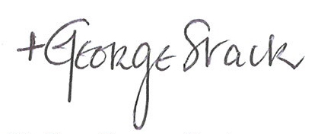
Bishop George Stack
Auxiliary Bishop for the Archdiocese of Westminster

National Office for Vocation

