APPEAL TEXT FOR PARISH AMBASSADORS
(Please feel free to adapt.)

INTRODUCTION
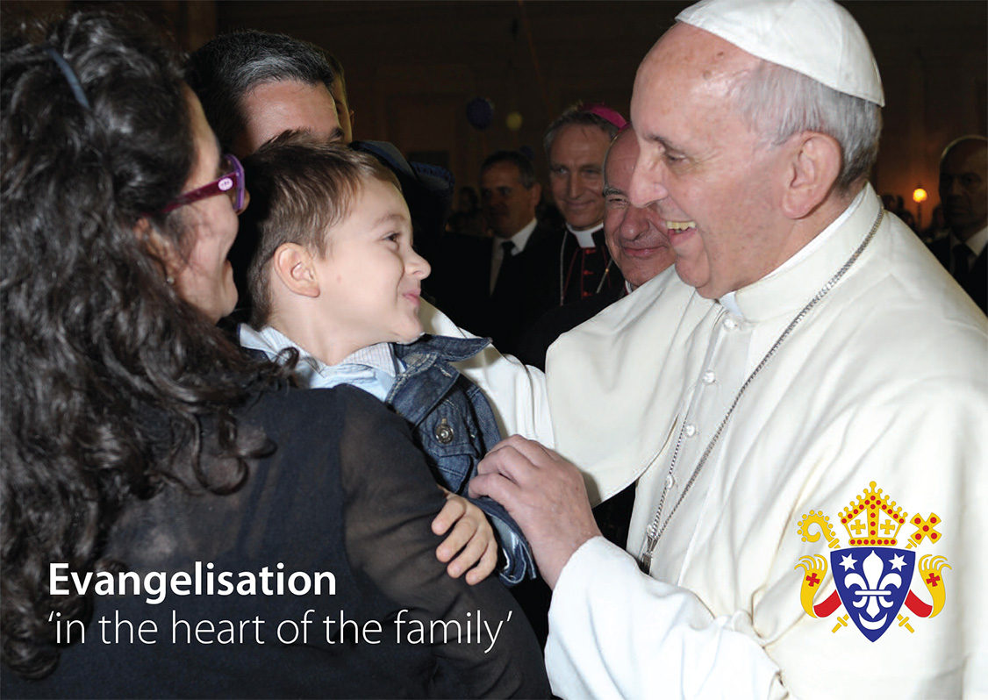
Good Morning / Evening, My name is (say your name) and thank you very much to Father (say his name) for giving me a brief moment to talk to you about today’s celebration of Home Mission Sunday.

AN URGENT TASK
Today the Bishops of England and Wales ask all of us to consider how we can play our part in the urgent task of Catholic evangelisation - the living and sharing of our faith in our families and in our local communities.

The reality is that, “many children and young people today will never see their [Catholic] parents receive the sacraments.” I’m sure, like me, you have observed this to be the case first hand, with many of perhaps our own family members, Catholic work colleagues and friends, rarely or never attending Mass, or enjoying any kind of connection with parish life.

In a moment of silence, may I invite you now to bring to mind those people you know to whom this applies. PAUSE FOR A MOMENT OF SILENCE

NOT ALONE
You may have brought to mind just now, your husband or wife, your son, daughter, grandchildren, niece or nephews, friends and others. You’re not alone. Research suggests that an estimated 80% of Catholics in England and Wales are non churchgoing (sometimes called ‘lapsed’) Catholics.

HOPE
Whilst this is not a new situation, there is hope. Every year non churchgoing Catholics in parishes across England and Wales do return to the practice of their faith if invited. The Bishops today ask each one of us to use the opportunities that present themselves, to invite people to re-connect.

SIMPLE WAYS
Often the turning point for a non churchgoing Catholic comes through a simple and authentic encounter. One example of this is found in the story of a young man called Matt who stopped going to Church as a student. He describes himself as: “the perfect example of a lapsed Catholic”. One of the significant moments in his journey of return to Faith, came when staying with a cousin, called Janie, who invited him and his wife to say the Rosary with her. Matt says that from that moment: “…it seemed things really took off for both of us. Janie's simple act of seeing the best in us, and not being too scared to spontaneously lead us in prayer, was both brave and inspired.” This encounter played a significant part in Matt’s return to the practice of the faith, and also in his wife’s decision to explore becoming a Catholic.

A CALL TO MISSION
So today, on 21 September 2014, the Bishops invite parishes to celebrate Home Mission Sunday, to pray for the work of Home Mission, especially for the advancement of the work of outreach to non churching Catholics. We are all invited to leave Church today resolved to do one thing to reach out to someone.

FREE PRAYER AND INFORMATION CARD
A free prayer and information card about the Sunday will be given out as you leave Mass today. You’ll see on that card a website for more information about the Sunday and how to access free resources and testimonies of hope.

THE BISHOPS NEED YOUR SUPPORT
The Bishops also ask today that you support the second / retiring collection as generously as you can please. Today is one of only three mandatory collections they ask parishes to take each year please, so that more resources and initiatives can be developed to reach out to non churchgoing Catholics whom we all love and respect. The money raised is vital to the development of this expression of Home Mission.

OUR PARISH
If you’re interested in possibly starting a parish group to reach out to and welcome non churchgoing Catholics, please do come and see me after Mass, and / or see Father. (Or if you already have an evangelisation group in the parish, or are involved in an existing diocesan evangelisation project, please use this moment to promote that.)

THANK YOU
Thank you in advance for your support of this vital ministry and work. Please do say the prayer provided on the postcards that will be given out.
Finally, to quote Pope Francis: “For if we have received the love which restores meaning to our lives, how can we fail to share that love with others?” (Evangelii Gaudium 8)

Someone that you know is waiting for YOU to share God’s love with them today.

Thank you and God bless you.

Approximate Length: 4 – 5 mins

Supplied by the Home Mission Desk, CBCEW
Email: homemission@cbcew.org.uk Tel. 020 7 901 4818
© Appeal text: CBCEW 2014
© Photograph: Servizio Fotografico de "L’Osservatore Romano” 2014.
CATEW: A company limited by guarantee and registered in England and Wales. Company No. 4734592 Registered Charity No. 1097482.

Taken from the preparatory document for the forthcoming Synod on the Family 2014.

