Reflections
for
Advent & Christmas 2009/2010

The Year of Luke

Rt. Rev. Christopher Budd
Bishop of Plymouth
Every high priest has been taken out of mankind and is appointed to act for men in their relations to God, to offer gifts and sacrifices for sins; and so he can sympathise with those who are ignorant or uncertain because he too lives in the limitations of weakness. That is why he has to make sin offerings for himself as well as for the people. No one takes this honour on himself, but each one is called by God, as Aaron was. Nor did Christ give himself the glory of becoming high priest, but he had it from the one who said to him: You are my son, today I have become your father, and in another text: You are a priest in the order of Melchizedek, and for ever.
Introduction

“You are a priest of the order of Melchizedek, and for ever.”
Hebrews 5, 1-6

Pope Benedict has dedicated this year as the Year for Priests.

In response to this invitation to pray for our priests, I have at the end of each reflection suggested a prayer for some aspect of a priest’s ministry.

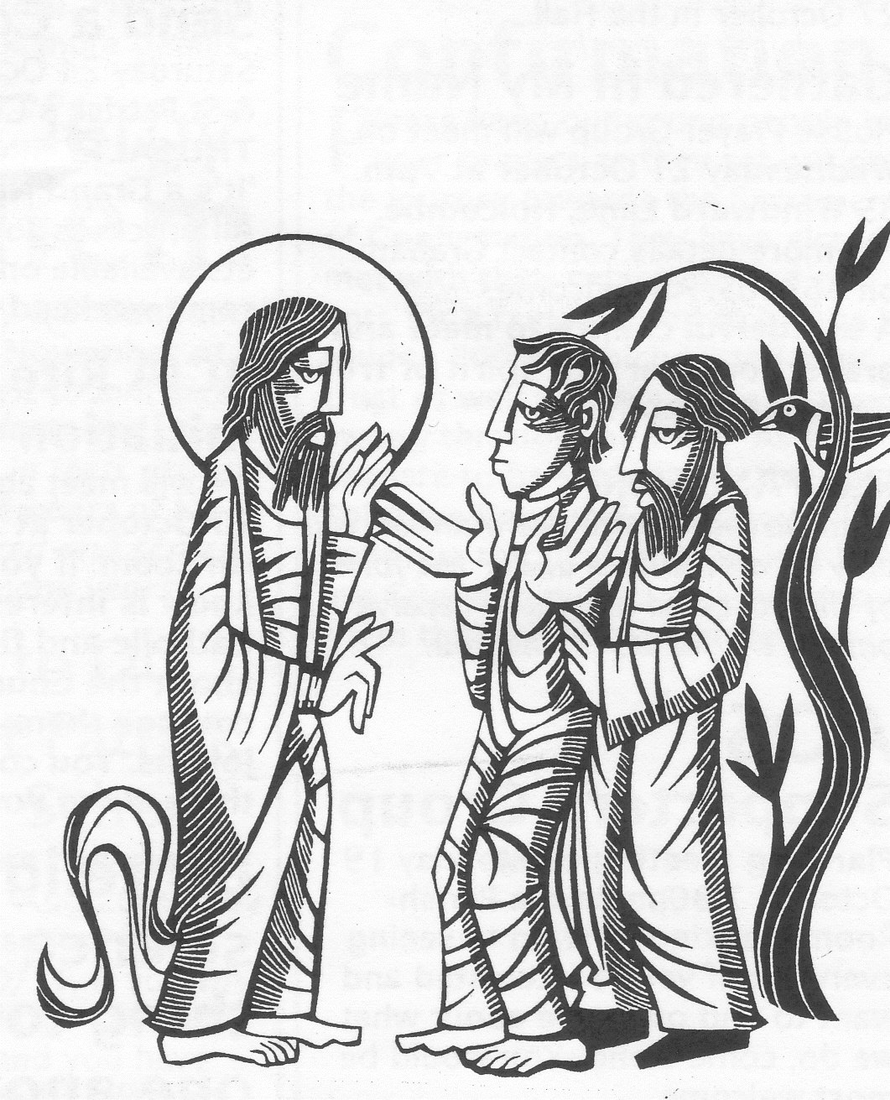
Our priests are a part of the gift of Christ to our world and to us. What they can offer us during their ministry becomes what we can offer our world as a sign and symbol of its redemption by Jesus.

FIRST SUNDAY OF ADVENT

WHAT OF THE FUTURE?

Jeremiah 33:14-16; 1 Thessalonians 3:12-42; Luke 21:25-28; 34-36

Knowledge is power. If we know the right or relevant things, we can control everything that affects us. One of our fears about the future, or more particularly my future, is that I will not be in control. A feature of providing care for our elderly people is the question, who is in charge? There is for all of us here an issue of trust. Whom do I trust? Experience of life has taught many to trust very few, if anyone.

At the end of a cycle of worship and celebration, the Church annually returns to variations on this theme. About what shall I be judged is the subject of the last couple of Sundays, while the first Sunday of Advent picks up this theme: what does the future hold, if anything, for us and who is going to be in charge of it?

Christian revelation has a clear answer to this. Do not worry, no matter how ominous the signs are. Trust in me, the Lord says; get on with life as it is meant to be lived day by day and leave the future in the hands of the One and the only One who is in charge of it – the Lord of history.
For all our anxiety or worry we can do little about the future, except live in the present in a way that can give a hopeful message about our own future and the future of our race and universe.

There is much concern at the moment about the state of our planet and its very doubtful future. Some, if not most, of this fear is about the effect of the way we have selfishly used both planet and people for our own purposes with little regard to the welfare of the whole of creation.

If we wish to leave the future in the hands of the Lord, we may need to discover again in the present a new way of living simply, so that all our brothers and sisters may share in both the material resources of the universe and human community based on love.

If this Advent brings us to this realisation, perhaps it will enable us to have a celebration of Christmas that is not dominated by consumerism and one that takes seriously our responsibility in love for each other. Perhaps we may embody St. Paul’s instruction to the Christians at Thessalonica, “Make more and more progress in the kind of life that you are meant to live”.

Pray that our priests will bring to us a gospel
of hope about the future
SECOND SUNDAY OF ADVENT

JOHN THE BAPTIST AGAIN!

Baruch 5:1-9; Philippians 1:3-6; 8-11; Luke 3:1-6

Advent would not be the same if John the Baptist was not a part of it. Historically he fits in well. He was the last in a long line of holy people who gradually prepared us for the coming of the Lord.

But we are not just looking backwards; we are looking forward and John speaks to us now in the 21st century. He addresses us in the middle of an era in which much that is so crucially important for the well-being of our humanity, as well as our relationship with God, is at stake. On these next two Sundays we have an opportunity to take John seriously. Do listen to him.

This first of the two John the Baptist Sundays presents us with a lovely image of what preparation is all about – make the journey easier than it is at the moment. The notion of journey is worth staying with. Whose journey is it? In the first place it is the Lord’s. He is the journeyman! He comes looking for us and we need to look seriously at our lives in preparation for him.

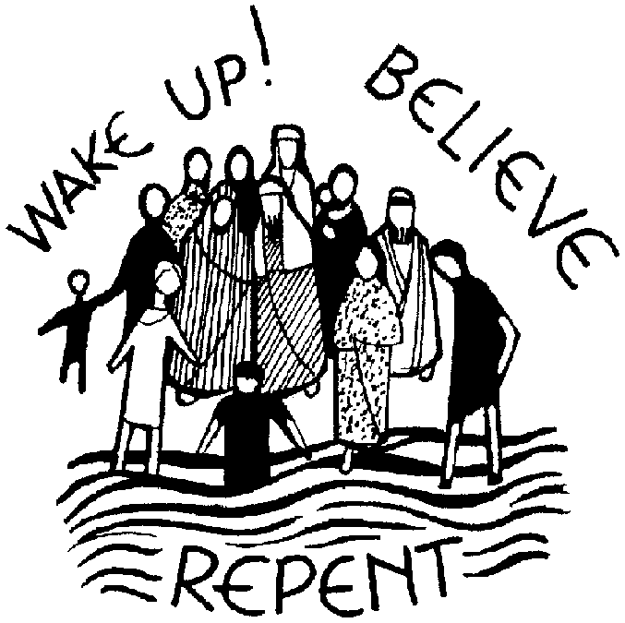
John invites us to get rid of the rubbish, so that the Lord can more easily find us and we can more easily recognise him, when he comes.

It is important to keep firmly in view that everything John speaks about is an initiative of God’s. We are helplessly lost without a living relationship with God and Christ comes about that. John points to our task of enabling Christ to enter in.

Even that is not principally our doing. It is the movement of the Spirit that enables the preparation to be embarked upon. Christ goes before us, Christ walks with us and Christ follows behind us.

If Jesus is the principal traveller, we also go out to meet him. Because Jesus travels towards us, we can journey towards him. Our meeting is the moment of salvation.

Pray that our priests will enable us
to be ready for Christ

THIRD SUNDAY OF ADVENT

GAUDETE SUNDAY

Zephaniah 3:14-18; Philippians 4:4-7; Luke 3:10-18

If John’s message about preparation is as useful as it seems to be, what does it mean in practice? Is there something we should be doing?

The answer is “yes” and it is to do with the integrity of our way of life. An important recent document about this is the present Pope’s letter Caritas in Veritate. Our lives are distorted because of sin, and sin has its roots in falsehood and self-centredness. To heed John’s summons, we need to start rebuilding our lives on truth – truth about God and about ourselves, and a sincere love for our brothers and sisters, not just those near to us but those who are far away.

The way we live and treat each another will always be distorted in some way by the fallout of our sinfulness. It is important that we start to put that right by seeking the truth about everything, and in the light of that truth to recast the shape of our lives with the justice that embraces our love for each other.

This is a big agenda, and it will most certainly require us to live more simply so that our integrity may shine out.

The prime enemy of integrity is pretence. If we really do live an integrity that comes from Christ, all the falsehoods that we cultivate around ourselves must go. That sort of agenda will see us through all the remaining Advents of our lives!

But do remember that all we do is to enable Christ to come and be welcome by me, by you and by many others. The work of integrity is very much the work of grace and the Holy Spirit.



Pray for our priests that they may lead us
to an honest and transparent way of living by word and example
FOURTH SUNDAY OF ADVENT

THE ARK OF THE COVENANT

Micah 5:1-4; Hebrews 10:5-10; Luke 1:39-44

One of the titles of Mary in her litany is the Ark of the Covenant. It is a lovely way of describing Mary’s relationship with God through her Son, Jesus. The Covenant is and has to be an initiative by and from God.


We cannot initiate any relationship with the Lord. We are non-starters. Everything we have is gift.

By amazing graciousness of God, we come into existence and in the power of that existence we can respond to God, especially in that closer relationship of love, which the image of Covenant so beautifully describes.

Mary is the bearer of this divine initiative. She is not just a messenger, but bears the Covenant in person, in the Son of God, Jesus Christ. The eternal Word becomes the enfleshment of God’s Covenant with us by becoming human in the womb of Mary, through the action of the Holy Spirit.

The Visitation tableau captures all this beautifully: in his mother’s womb John acknowledges the One, who is totally and absolutely unique, because of Who he is. His leap of joy is the only adequate way of recognising Jesus, God’s Son and Mary’s Son. John’s leap of joy is matched by Elizabeth’s greeting Mary as “the Mother of my Lord”.

The Covenant of God is the person of Jesus Christ, truly God and truly man. Mary is its Ark, its safe place and shrine as the Covenant of God’s love for us comes into our history.

Pray that our priests will lead us to Jesus,
God’s Son and Mary’s Son
CHRISTMAS DAY

THE WORD MADE FLESH

Vigil Mass - Isaiah 62:1-5; Acts 13:16-17; 22-25; Matthew 1: 1-25
Midnight - Isaiah 9:2-7; Titus 2:11-14; Luke 2:1-14
Dawn - Isaiah 62:11-12; Titus 3:4-7; Luke 2:15-20
Day - Isaiah 52:7-10; Hebrews 1:1-6; John 1:1-18

There are four distinct but precisely timed Mass liturgies for the Feast of Christmas. The readings, as always, are all worth hearing and pondering.

It is interesting to note that Jesus is still widely popular in our own day. It is a minority of people who would wish to demean him and rubbish his memory and his influence. That has to be good news to Christians everywhere.

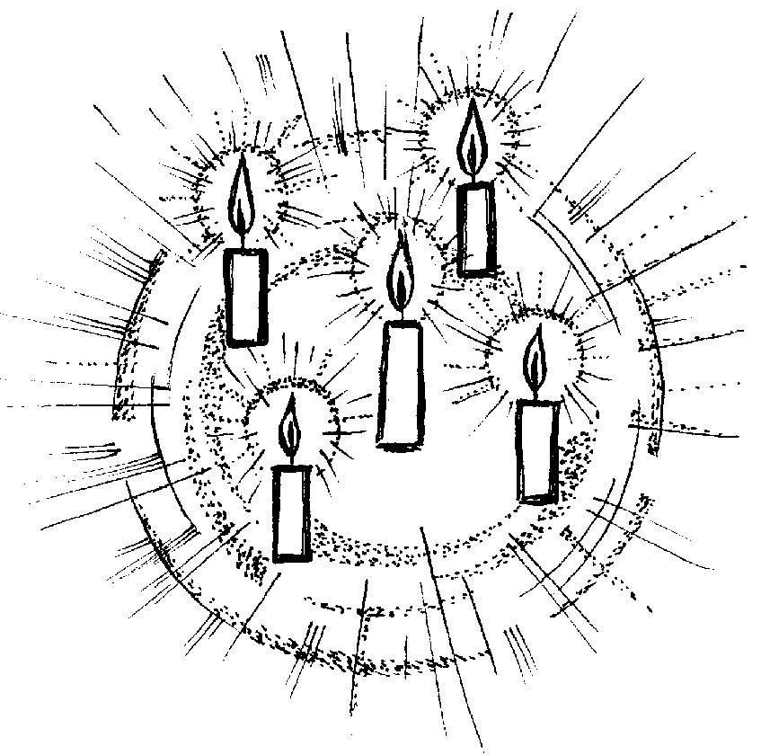
We, the disciples of Jesus, are responsible for his good name. We all know how frequently we can let him down by living in a way that betrays what Jesus is all about. Our contemporaries are good at calling us to account when we fail.

However, the Jesus that is seen as a “good bloke” is very different from the Jesus we believe in. We can all agree that Jesus was an outstanding human being, who bequeathed us a way of life that can contribute much to human flourishing: all that we can hold to and rejoice in without falling out. But the Jesus we believe in and can come to know in faith is the Jesus who is God.

That, as always, will be the crucial issue. Jesus’ identity is utterly central to understanding the way of life that he gave us. To identify Jesus in any way that does not acknowledge him as divine is to recreate him in our own image and likeness, albeit an idealised one.

If Jesus is an outstanding human being we can cope and relate to him comfortably. But, if we set his agenda, then we do not open ourselves to an agenda that is really beyond us and yet is made possible for us because God became one of us.

The incarnation, God made man, is pure gift - a gift to our humanity at its deepest level. Being made in the image and likeness of God means that, deep within us, there is a homing instinct that will not be satisfied until we rest in God.

In becoming man Jesus, God the Son, addresses us at that deepest level and says, “Come follow me”. We follow not a perfect human being, but God in human form, who shares our humanity, so that we can share his divinity. Christmas is all about that.

Any celebration of Christmas that is not based on “the Word became flesh” is in many ways a non-Christian celebration of a central mystery of our faith. Much that passes as celebration at Christmas totally misses the point. The campaign of putting Christ back into Christmas can also be misleading if it fails to put the full and real Christ, the Word made flesh, back into this Feast.

Much of our Christmas celebration is totally inappropriate because we are celebrating the birth of a Christ that has been constructed by ourselves. May I suggest that if we give ourselves space and time and listen carefully to the liturgy of the Church we will find the real Jesus.

Pray that our priests will lead us to the real Jesus
HOLY FAMILY

The reality of family

1 Samuel 1, 20-22, 24-28; 1 John 3, 1-2, 21-24; Luke 2, 41-52

It would be misleading to think of this Feast in the bosom of the celebration of Christmas as an attempt to set some pretty demanding standards for family life.

After all, if we have a family, as we do, that is made up of the Word made flesh, Mary the mother of the Word made flesh and a saintly foster-father, St. Joseph, where would we start?! Getting anywhere near this family seems well out of our reach!

First of all this Feast endorses and affirms that, if the Lord is truly one with us and one of us, some fundamental institutions like the family and its well-being will be touched and transformed by the presence of the Word made flesh.

Having taken on our human nature, He took on all the things that are fundamental to being human. Family is one of those. This needs to be reaffirmed, not aggressively but with a confidence that comes from God and from Christmas.

Without getting involved in contemporary discussion about what can count as family, the Christian insight that will always be foremost in our thinking is that the family unit is made up of loving commitment between parents and children, and that love is ongoing. The ravages of sin in this area are only too obvious to see, not just in our own age, but in our history.

But the Holy Family does model something for us, something that is far from impossible. Because of the Word made flesh, it is possible to live a family life that is based on love. This is a love that is not like the morning mist, but one that can endure hurt and can be sustained and strengthened through forgiveness. Love that is the cement of all loving relationships ultimately endures because it is sustained by the Spirit of the Lord.

Today’s Gospel, being one of the infancy snapshots in our Gospels, shows love in the family at work in a crisis situation. The young Jesus goes off by himself and causes considerable distress to the parents. Where the things of God have priority, as in this story, love that is truly non- selfish will thrive. Perhaps we need to fully understand that this is the primary element in family life.

Pray that our priests will always minister
to our families
NEW YEAR’S DAY

THE MOTHER OF GOD

Numbers 6:22-27; Galatians 4:4-7; Luke 2:16-21

This day used to be dedicated to the circumcision of the Lord. It is not excluded from this new feast, as witness the Gospel, but it takes a back seat.

In instituting this feast of Our Lady, the Church really wishes to underscore the importance of Mary in the story of redemption. If Mary is really and truly the mother of God, her Son, Jesus Christ, is really and truly one of us. We cannot fully and adequately identify Jesus unless we give Mary her place in his life and ministry, as the mother of God full of grace.

She is the one through whom God’s blessing for us mortals came into our history in visible and tangible form.

The lovely blessing of Aaron in our first reading is fulfilled in the person of Mary and Jesus, as the blessing becomes flesh in our history. Christian art has captured this blessing so well, more often than not by portraying mother and child together.

However, do not forget the background of the circumcision. Jesus fully identified himself with his people through this ritual and physical act, since Mary and Joseph fulfilled their obligations as Hebrews to carry out the Father’s design that his divine Son should come into our history fully a member of a particular people, the Jews. Being human involves all that.

Why did he choose the Jews? An unanswerable question, but we owe a debt of gratitude to that people for our greatest gift.

Pray that our priests will lead us to a love
of our Jewish brothers and sisters

THE EPIPHANY

THE LIGHT OF ALL PEOPLE

Isaiah 60:1-6; Ephesians 3:2-3; 5-6; Matthew 2:1-12

The crib scene, so precious to us, is peopled with familiar figures. We know immediately if someone is missing and ask what has happened with this one or that one. We know them all and, after a fashion, we protect their interests!

The Gospel story is somewhat different. We can call the Epiphany ‘the Christmas of the Gentiles’, and rightly so. The shadowy people from the East represent those not of Jewish descent who come looking for Jesus. Jesus comes for everyone, Jew and non-Jew alike.

But it is easy to lose touch with a rather challenging side of the Epiphany story. Our visitors from the East are not invited guests. They are strangers. We lose touch with that at the peril of losing an important dimension of our feast today. They are above all outsiders or strangers. It is worth noticing what happens. When they come to Herod, he immediately sets about seeing how he can use them for his own purposes. Herod’s welcome is phoney. They are only really welcome if they do his bidding. And we know what happened when Herod found out that they were not putty in his hands! We had a massacre of innocents.

When they find Jesus and his family, they cease to be strangers and are welcomed into that family. No-one wishes to manipulate them because they are seeking the truth and they find the truth in Jesus. In that truth strangers become friends, because truth will always enable strangers to engage personally with each other and in that way to belong.

This is an important aspect of the Feast of the Epiphany, which says that everyone is welcome because of the Word made flesh. The challenge to us is to live that as fully as possible.
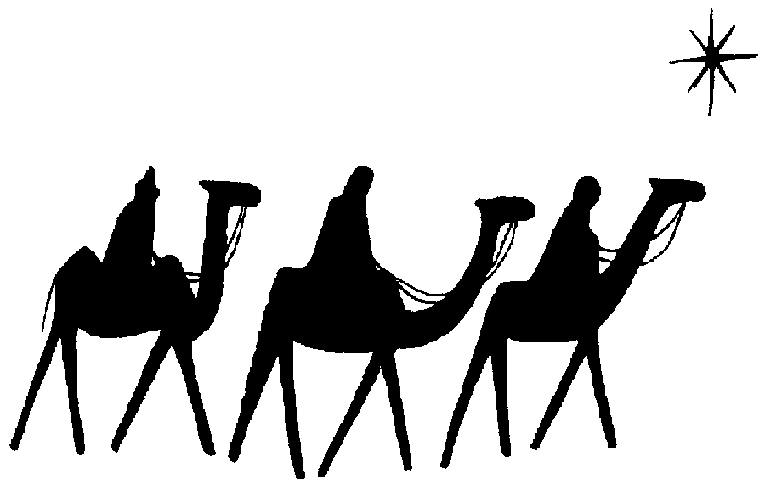

Pray that our priests will lead us to
welcome all strangers

JESUS IS BAPTISED

AN EMPTY GESTURE?

Isaiah 40, 1-5, 9-11; Titus 2, 11-14, 3,4-7; Luke 3,15-16, 21-22

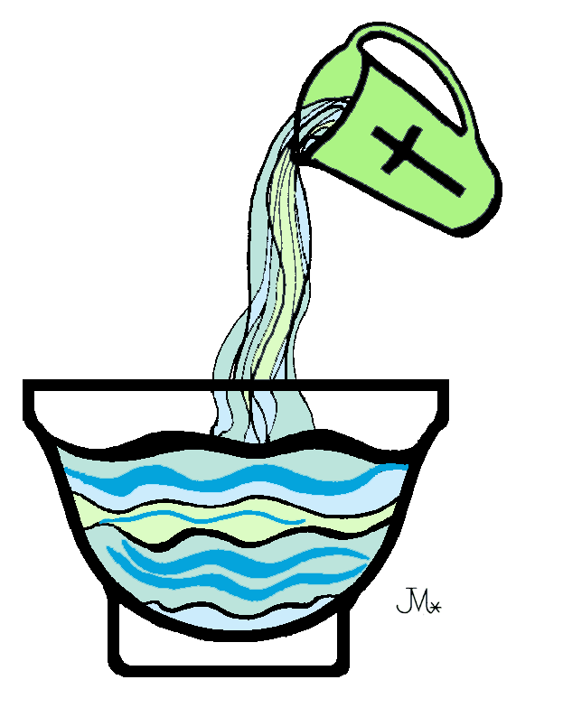
The Christian Scriptures and the Church’s living tradition are adamant that Jesus is the sinless one. There can be no doubt about it at all! After all, how can the One, who is God made man, be involved in anti-God activity! No matter how we dress it up, sin is living in a godless way. Perhaps on a feast like the Baptism of the Lord we could usefully reflect on the nature of sin and conversion. We will not understand the work of redemption unless we do.

However, the main focus of this feast is on Jesus the Lord at the beginning of his ministry among his own people, a work ultimately for all humanity and the whole of creation.

In the River Jordan, Christ does two things. First, he consecrates the waters of baptism in such a way that they cease to be a mere outward sign of a claimed conversion of heart. They become an outward sign of something that happens deep down in the heart of the person coming to baptism.
We are dealing with the remedy for our sinfulness or alienation from God. The recognition of Jesus by the Father and the descent of the Holy Spirit say very clearly that dealing with our sinfulness is something that God, and only God, can do. In dealing with our sinfulness Christ is showing himself to be the Lord.

The other thing happening on Jordan’s banks is that Jesus shows his solidarity with us. It is not solidarity with our sinfulness, but with us as alienated creatures of the Lord. He tackles this alienation from the inside. Jesus is grace in person; his presence in our humanity spells the end of sin, but not without a life and death struggle. Ultimately the victory is won through Calvary and Easter Morning.

Pray that our priests will lead us to never disown our sinfulness, but recognise it for what it is
– our responsibility for our alienation from God and the opportunity for God’s grace
to change us profoundly.

May they lead us to a renewed appreciation and practice of the Sacrament of Reconciliation





Bishop’s House
Plymouth

