9th June 2006

Ms Melanie Field
Director: Discrimination Law Review Team
Women and Equality Unit
1 Victoria Street
London SW1H 0ET

Dear Ms Field,

“Getting Equal” Consultation

I am enclosing with this letter a response on behalf of the Catholic Bishops’ Conference of England and Wales to the above mentioned Consultation. We are most grateful to you for allowing us to submit this slightly later than required by the deadline.

As you will see, we have serious concerns about these proposals which we believe, as they stand, could gravely infringe the rights of Churches, religious organisations and other major Faiths, recognised by the Human Rights Act 1998. As you will also be aware, similar concerns have been raised in the submissions of the Church of England, the Catholic Bishops’ Conference of Scotland, Caritas-social action, as well as other Christian Churches and groups, and we would think by those representing other major Faiths.

We should be happy to discuss all these matters more fully with Ministers and officials so that suitable exceptions can be made before the draft regulations are laid before Parliament.

Yours sincerely,

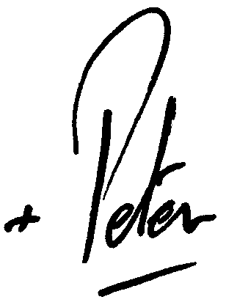

Archbishop Peter Smith,
Chairman, Department for Christian Responsibility and Citizenship

