

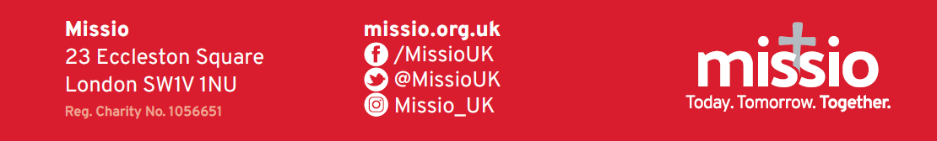
WORLD MISSION SUNDAY 2023
‘Hearts on fire, feet on the move’
Inserts for your Parish Newsletter

To help support Missio’s World Mission Sunday appeal, a simple QR code has been created which will help the faithful give a gift simply and securely online.
Please include this QR code in your Parish Newsletter, if you can, with the following instruction: To donate to World Mission Sunday, simply scan this QR code using your phone. To give a gift, you can also visit Missio’s website: missio.org.uk/wmsdonate



Sunday 15 October 2023 ‐ Next Sunday is World Mission Sunday
Next Sunday is World Mission Sunday, when the Holy Father invites all Catholics to contribute to a special collection for Missio, his charity for world mission. Please support Missio in helping missionaries to work alongside communities throughout the world that are poor or in need, regardless of their background or belief. Join in on this special day, that unites Catholics all over the world in prayer and celebration of our Church’s mission to share God’s love with all people. If you use the donation envelopes to give by credit/debit card, please return the envelopes directly to Missio. Do not put them in the Church collection. Please call 020 7821 9755 (office hours) or visit Missio’s website to give a single gift, set up a Direct Debit and Gift Aid your donation if possible: missio.org.uk

Sunday 22 October 2023 ‐ Today is World Mission Sunday
World Mission Sunday is being celebrated in every Catholic parish around the world today! It supports missionaries who work alongside communities that are poor or in need, regardless of their background or belief. By supporting Missio, the Pope’s charity for world mission, you will help missionaries like Sr Mary in Kenya who has given her whole life to bring the love and hope of Jesus to situations of poverty and injustice. Please pray for the mission of the Church throughout the world and give what you can to this very important collection which will sustain the future of our Church. If you use the donation envelopes to give by credit/debit card, please return the envelopes directly to Missio. Do not put them in the Church collection. Please call 020 7821 9755 (office hours) or visit Missio’s website to give a single gift, set up a Direct Debit and Gift Aid your donation if possible: missio.org.uk

Sunday 29 October 2023 ‐ Thank you for supporting World Mission Sunday
Thank you very much for your donations to World Mission Sunday last week. Your prayers and support of World Mission Sunday will help missionaries work alongside communities throughout the world that are poor or in need, regardless of their background or belief. Please pray for the work of Missio and all those working to offer the love of Jesus, that we may remain strong in our witness to Christ’s love for all peoples. To continue supporting mission throughout the year, please go to missio.org.uk or call 020 7821 9755 (office hours).

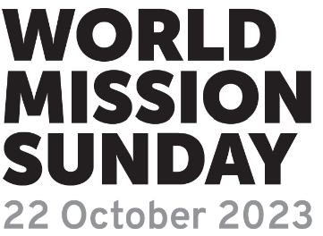
Your questions answered
Q: When is World Mission Sunday in 2023?
A: Sunday 22 October 2023
Q: Why are all parishes throughout the world asked to support World Mission Sunday?
A: World Mission Sunday is vital to the growth of the Church and the spread of the Gospel in predominantly impoverished and remote areas overseas. The funds raised build much-needed infrastructure, from chapels and schools to orphanages, clinics and dispensaries. Requested by the local community, the support from Missio transforms lives and creates a hub from which the young Church can flourish and grow. World Mission Sunday is one of only three Papal collections and has been especially chosen by the Holy Father to support the mission of the Church in the world via Missio.
Q: Where do I send the World Mission Sunday collection?
A: Please send donations from your parish directly to Missio in the Freepost envelope provided. Cheques from parishioners, made out to World Mission Sunday or Missio, can be sent directly to us together with the parish collection and any completed Gift Aid forms and Donation envelopes. Please do not send to your diocesan offices. If parishioners wish to complete the form on our prepaid Donation envelopes to give by card, please ask them to return these directly to Missio, rather than place them in the parish collection. They will be added to your parish total.
Q: How can I donate online?
A: Individual supporters can give directly through our secure website. Simply visit missio.org.uk/wmsdonate to help build a future of hope around the world.
Q: How can we continue supporting Missio after World Mission Sunday?
A: Missio raises funds for the overseas mission of the Church through the APF‐Mill Hill Red Boxes which are in around 200,000 Catholic homes.
Throughout the year, Missio works in partnership with the Mill Hill Missionaries to raise funds and awareness for overseas mission through the Red Box. If your parish does not already promote the Red Box, please consider an appeal after World Mission Sunday. Other important ways of supporting the mission of our Church include praying for the work of missionaries and volunteering for Missio.
You can also support overseas mission by sending Mass stipends to overseas priests via Missio.
An overseas priest can say Mass for your intentions and at the same time receive much‐needed financial support. Please call us on 020 7821 9755 or visit missio.org.uk/mass‐oﬀerings
Q: What is the diﬀerence between World Mission Sunday and Home Mission?
A: World Mission Sunday is a Papal collection taken at Mass on the penultimate Sunday in October. It goes to support the 1,070 dioceses in 157 countries around the world where the Catholic Church is too new, young or poor to survive without our help. Home Mission is the collection for evangelisation and outreach in England and Wales only and is Coordinated by the CBCEW.
For more answers to your questions, please call 020 7821 9755 during oﬃce hours
or email info@missio.org.uk

