OUR EASTER JOURNEY
Reflections through art
for individual or group meditation.

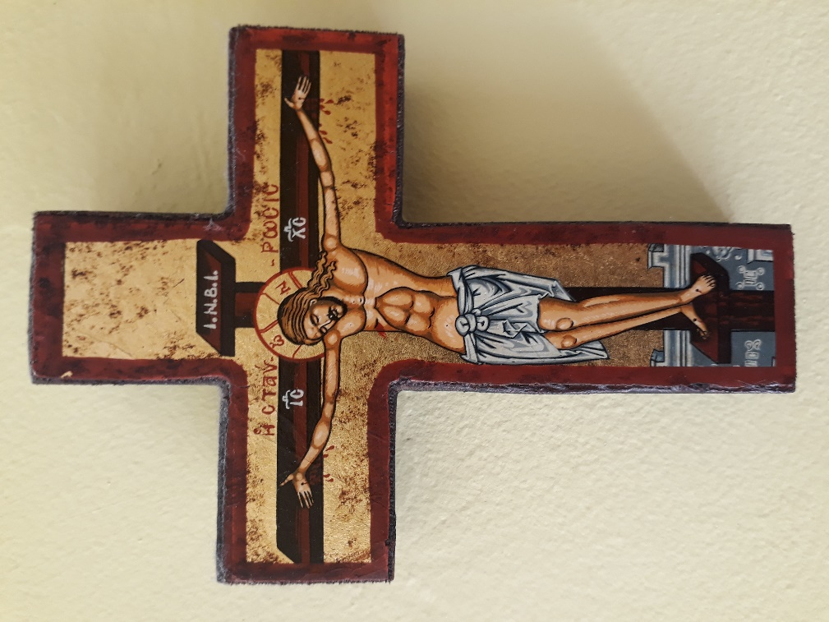
Private collection. Fleur Dorrell.

The Painters’ Path from Palm Sunday
to the Second Sunday after the Resurrection



PALM SUNDAY

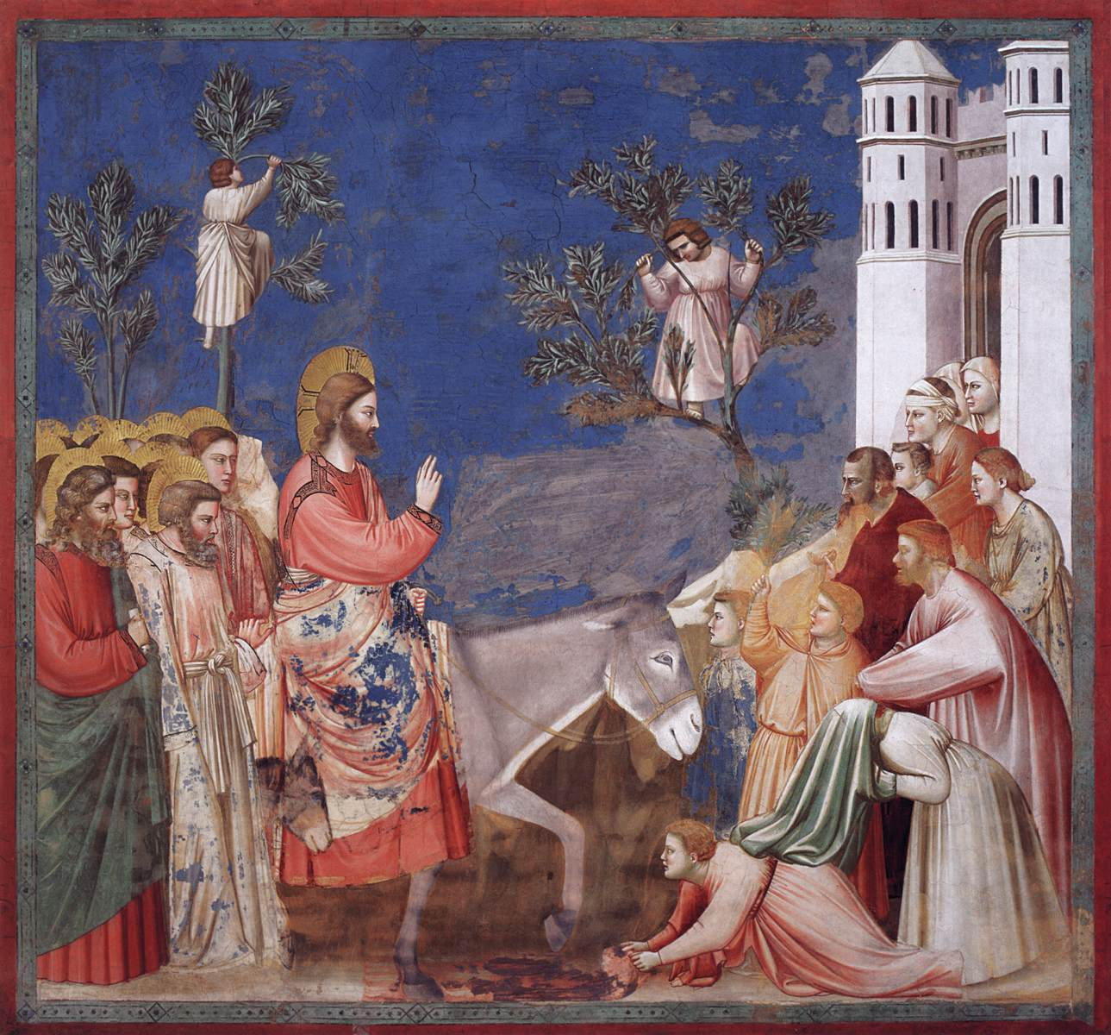

The Entry into Jerusalem, c.1304-06 – Giotto.
Fresco from the Scrovegni (Arena) Chapel, Padua, Italy.
https://www.wga.hu/html_m/g/giotto/padova/3christ/chris10.html
Used with kind permission from the © Web Gallery of Art.

Read today’s Scripture
Matthew 21.1-11 – The triumphal entry into Jerusalem.

Opening meditation
Blessing on him who comes in the name of the Lord.
Blessing on all who follow God this day.
The donkey carries Christ and crowds wave palms in joy.
This is the journey of a king, yet one who is to die.
Let us bow down in homage as he passes by.
Meditation on the painting
Jesus has been travelling from Galilee to Jerusalem. He’s been teaching and healing as he travels, and preparing his disciples for what lies ahead. The entry into Jerusalem is the pivot between all that Jesus has been doing and teaching and all that lies ahead of him - when he will suffer violence, betrayal and death. Here in Matthew’s text and Giotto’s painting, Jesus rides with dignity towards his crucifixion for the sake of our salvation.

The artist has placed Jesus in the centre of this fresco with the disciples crammed together on the left, their golden haloes vying for attention. They are both curious and unsettled, cautious and wary. Jesus has prepared them for the events to come, for his arrest and death, but they are still afraid, afraid of the unknown. How will it all end?

The people on the right are very different as they flow out of the city of Jerusalem. Here are both men and women and their faces are more visible - they want to meet Jesus. They are hopeful and joyful at what he promises. While this unusual procession is taking place, two eager people are in the trees picking palm branches to honour Jesus. You can almost see the branches about to sway with their weight. The man in the tree on the right holds his arms in a crucified position foretelling Jesus’ fate.

The azure blue sky offers us warmth and definition while at the bottom right one man rolls out his cloak in a royal gesture – the red-carpet treatment. Two other chaps are still getting their cloaks off to follow suit. Notice how Giotto includes not just the magnificent and prominent donkey but also, the endearing little colt at the bottom left. And if you listen well, you can almost hear the crowds shouting, ‘Hosanna to the Son of David! Hosanna in the highest heaven!’ For Matthew and for his Jewish readers these terms would hold historical and theological significance, since this crowd understands that Jesus is the promised King.

Jesus looks almost three-dimensional in this picture, offering a gesture of peace and blessing with such messianic dignity. In riding on a donkey, we see his nature and his invitation to us all: ‘The Son of Man comes not to be served but to serve.’ Christ’s blessing with two fingers pointing upwards symbolises both his humanity and his divinity. Very soon, he will be the subject of lies and ridicule, desertion by his friends, senseless violence and a brutal death, yet Jesus’ focus is not on himself. He offers peace and blessing along his path.

See how the donkey takes centre stage as she steps forward boldly and obediently with her colt at her side, mirroring Jesus as the faithful servant of God. This donkey is focused which you can see in her confident stride. She is fully aware of what is going on. With one ear pointing backward and one pointing forward, she’s attuned to her master and to the crowd. She is a bridge between what is past and what lies ahead in the salvation story.

As we follow Jesus, he is passing in front of us. Let us watch and adore.

Questions for reflection
Where would you place yourself in this painting?
What strikes you about this Scripture text and painting most?
What is God saying to you today?

Closing Prayer
End with a prayer of your choice, or with the Our Father, Hail Mary and the Glory Be.
Amen.

MAUNDY THURSDAY

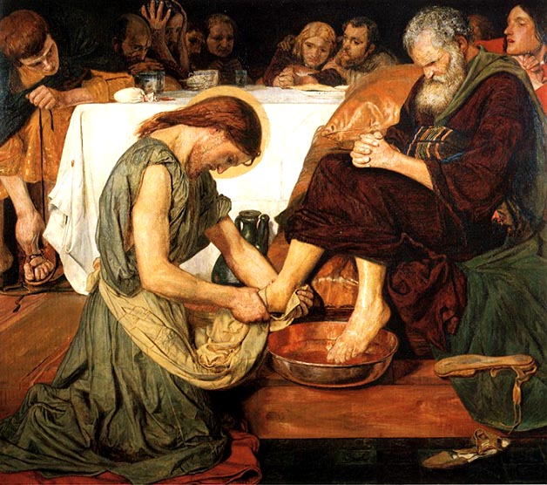

Ford Madox Brown, Jesus Washing Peter’s Feet, 1852-6, Tate (N01394), digital image. © Tate released under Creative Commons CC-BY-NC-ND (3.0 Unported), tate.org.uk.

Read today’s Scripture
John 13. 1-38 - Jesus washing the disciples’ feet.

Opening meditation
I give you a new commandment:
love one another just as I have loved you, says the Lord.
I give you a new gift of service:
when you care for each other, you care for me.
Let us kneel down and serve God’s holy name.

Meditation on the painting
With such a low viewpoint and intimate space, we’re not simply observing this painting – we’re invited into this room to be with Jesus and the disciples.

Shortly after Jesus and his friends had celebrated the Passover together, Jesus rose from the table and began washing their feet. In Jewish and Roman custom, this was regarded as a most demeaning task, and therefore, was usually done by a household slave. For Jesus, the Son of God, to wash smelly, human feet was nothing short of a scandal. Just look at the disciples’ expressions around the table.
Then Jesus calmly laid aside his outer garment – the Greek word tithēsin means ‘to lay aside’. As he lays aside his clothes, so he lays aside his divinity to wash those whom he loved. He would have his clothes forcefully removed when he laid down his life on the cross. He would himself, lay his clothes neatly aside in the tomb, as he rose from the dead.
Jesus tells Peter that there’s a spiritual significance to this simple task that Peter won’t understand until “later” - ‘later’ in the Greek implies after Jesus’ death - that we all sin, and we cannot clean ourselves, and we only need to be washed once in this way. Perhaps this is a nod towards baptism. Jesus is insistent. The disciples cannot have real fellowship with him unless he washes their feet.
Is Peter terrified? Who wants to follow a God who does this kind of thing? Peter’s ‘never’ - “’You will never wash my feet’…” in Greek is an emphatic no - as in ‘never in my lifetime’, rather than a polite, ‘No thank you Jesus, not today if you don’t mind’. Whose feet would he, Peter, now have to clean? Perhaps, as Peter addresses Jesus three times, (twice as ‘Lord’ and once as ‘you’), Peter knows he will doubt Jesus at the end, will deny him three times. So this is a warning of what he cannot fulfil.
Maybe, by letting Jesus wash his feet, it’s just too much to bear. It’s better to remain at a safe distance. Or is Peter sad for Jesus, that his Lord and master is humiliating himself with this task? Is it a loving plea to retain some dignity and divinity here? Yet, while Jesus, in his grasshopper green robe, calmly continues washing Peter’s feet, a storm is brewing in Peter’s head. See those frown marks, Peter's awkward, intense concentration, his clenched hands.
Here Jesus is neither master nor servant but an equal with the disciples. They’re all on the same footing. So the real power here is the foot-washing, the power of transformative love. This Gospel story reverses our obsession with ourselves and forces us to bend low (quite literally) to anyone we meet. If Jesus, our Saviour, will wash feet, what can stop us? Jesus washes all of his disciples’ feet, including Judas. Judas is seated on the far left - lacing up his sandals. His feet have been washed already, while his white moneybag lies on the edge of the table securing Jesus’ imminent death. In contrast, John the beloved disciple sits on the far right. Jesus’ love is unconditional. It is grace towards everyone, including those who betray him.
Questions for reflection
Where would you place yourself in this painting?
What strikes you about this Scripture text and painting most?
What is God saying to you today?

Closing Prayer
End with a prayer of your choice, or with the Our Father, Hail Mary and the Glory Be.
Amen.

GOOD FRIDAY

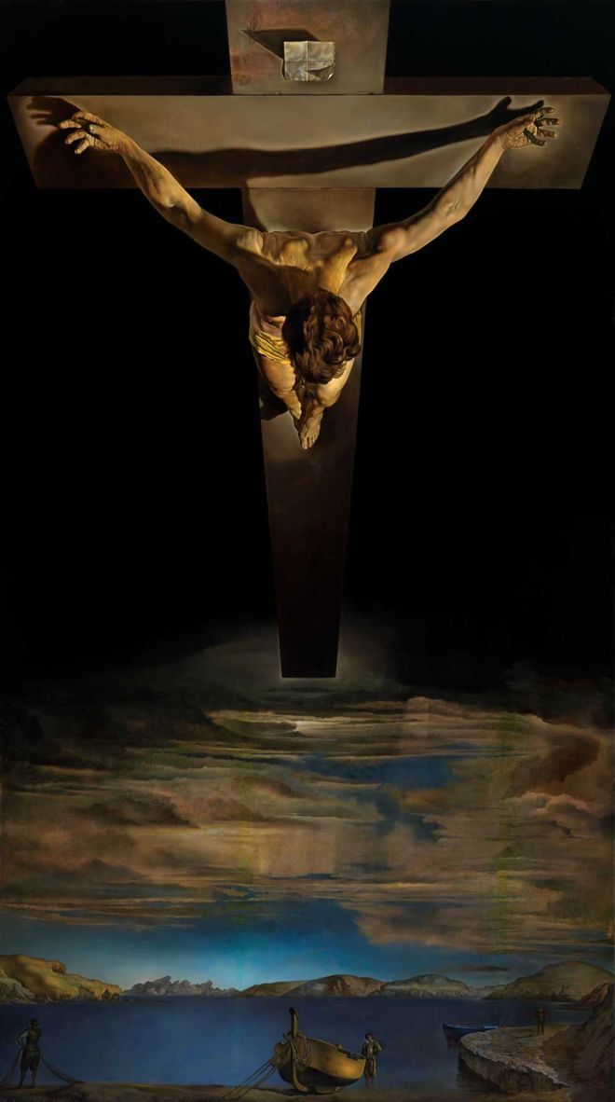

Christ of St John of the Cross, 1951 – Salvador Dali.
Kelvingrove Art Gallery and Museum, Glasgow.
https://en.wikipedia.org/wiki/Christ_of_Saint_John_of_the_Cross#/media/File:Christ_of_Saint_John_of_the_Cross.jpg

Read today’s Scripture
John 18.1-19:42 – The Passion of our Lord Jesus Christ.
Opening meditation
The temple curtain was torn in two,
and darkness covered the land.
God-made-man bowed down his life,
for he was ever bound to death.
In one last breath, he crossed out sin for love.
Meditation on the painting
This painting is in direct contrast to yesterday’s, with its high viewpoint and perspective, portrayed from above the earth, looking down. It is the heavenly perspective that only God can see and is the most-viewed portrayal of the crucifixion in the world.
Christ of Saint John of the Cross is a painting by the Surrealist Salvador Dali made in 1951. It depicts Jesus on the cross in a darkened sky, hanging over a body of water complete with a boat and fishermen. Although it is clearly the crucifixion, it has none of the usual elements of this episode in Christ’s life. We notice that are no nails in Jesus’ hands and feet, no blood seeping from his side, and no crown of thorns around his head.
Dali was inspired to paint this scene by a crucifixion sketch that the Spanish Carmelite and mystic, St John of the Cross, drew in 1550; and by a dream that indicated to Dali, that the typical passion story features would spoil his depiction of Christ in his perfect form. In Dali’s dream, the importance of portraying Christ at such an unusual angle was also revealed to him. The composition of Christ was based on a triangle and circle. The triangle is formed by Christ's arms and points down towards his feet; the circle is formed by Christ's head. This triangle symbolises the trinity, and the circle (in Platonic thought) represents ideal unity. The combination presents us with perfect harmony.
In order to recreate the figure of Christ realistically, Dali arranged for the Hollywood stuntman Russell Saunders to hang from an overhead gantry. Dali was able to see how the body would appear from the desired angle, and to envisage the precise pull of gravity on the human body. No artist had portrayed Christ in this way previously. It offers us a unique visual understanding about Christ’s death: that he perfected his divinity in his humanity.
The water below is the Spanish bay of Port Lligat, where Dali lived. Yet it also represents new life. Cleansed by Christ’s death and resurrection this lake becomes a sign of baptism. The boat moored in the front reminds us of Jesus calling the disciples to be fishers of men. The mountains in the background refer to the countries that Jesus commanded the disciples to go and preach in, of where the Gospel, over successive generations, would spread.
Jesus is outstretched, outcast, outlived but not outdone. Here we see in motion, that Christ’s paschal mystery unites the divine and human. Dali invites us to be caught up into the divine, as our eyes travel up and down the canvas. God our Father, offers us his Son, but are we willing to change our own perspective to witness to this truth? Do we want to live it and share it, no matter the cost?
Questions for reflection
Where would you place yourself in this painting?
What strikes you about this Scripture text and painting most?
What is God saying to you today?

Closing Prayer
End with a prayer of your choice, or with the Our Father, Hail Mary and the Glory Be.
Amen.

HOLY SATURDAY

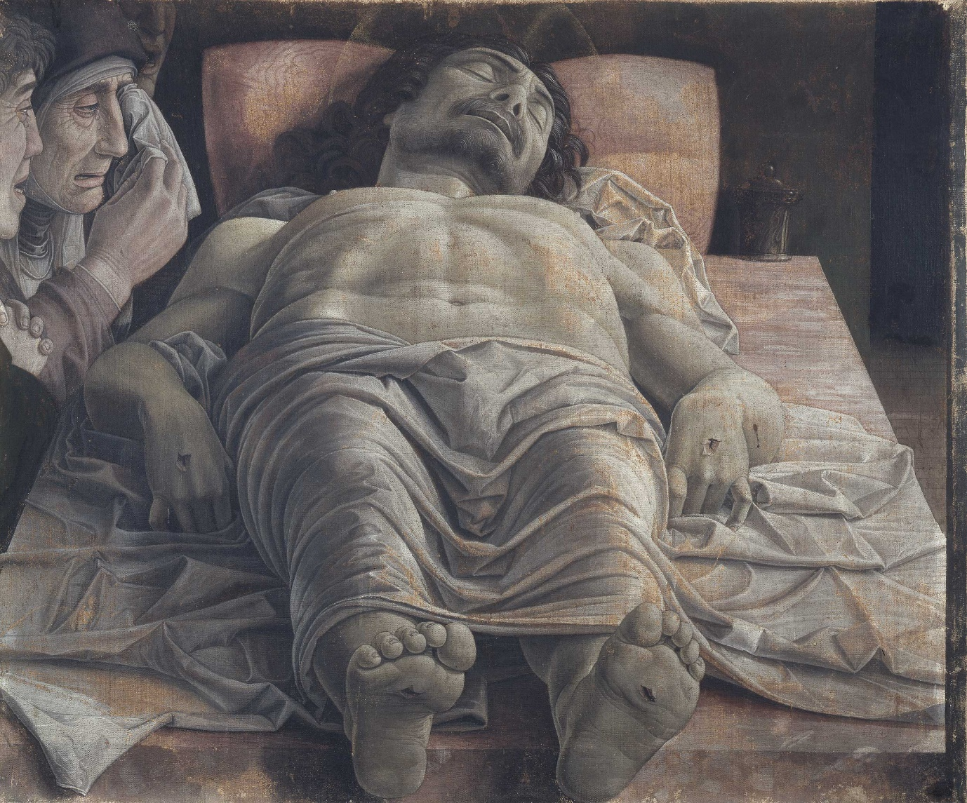

Lamentation over the Dead Christ, c.1483 – Andrea Mantegna.
Pinacoteca di Brera, Milan.
https://pinacotecabrera.org/en/collezione-online/opere/the-dead-christ-and-three-mourners/

Read today’s Scripture
Mark 15. 42–47 – The Burial of Jesus.

Opening meditation
They took him down to raise him up
and laid him low inside a linen cloth.
With oils and spices they honoured death
and wrapped him sure in love and faith.
It was a new tomb for a new Messiah.

Meditation on the painting
Holy Saturday is the day in the Christian liturgical calendar that celebrates the 40-hour-long vigil that the followers of Jesus Christ held after his death and burial on Good Friday, and before his resurrection on Easter Sunday.
According to the Bible, Jesus' followers and family held a vigil for him outside his tomb, awaiting his foretold resurrection. Biblical references to this vigil are short, but accounts of Jesus’ burial are in all four gospels: Matthew 27.57–66; Mark 15.42–47; Luke 23.44–56; John 19.38–42 and it is interesting to compare them.
Here we have another extraordinary viewpoint and perspective on Christ’s passion, watched over by his mother Mary, St John the beloved disciple, and St Mary Magdalene mourning Jesus’ death.
Mantegna’s dramatic foreshortening evokes an immediate emotional impact because he draws our eyes directly to Christ’s body without any warnings or barriers. Mantegna’s skill in recreating this scene in such forensic detail is outstanding, as he takes us on a journey around a dead body at rest. Christ’s grey skin and shroud seem to emerge from the marble slab beneath his supine body, and yet remain unyielding with rigor mortis. Just look at the toes on Christ’s right foot coupled with those awkward wrists and bent fingers.

The longer we linger over this painting, the more fascinated we are by this illusion of perspective and pallor. We cannot but help hover over Christ’s body, his muscular frame and open wounds, his thorax rising in front of his chin, and his curls of hair adding to the endless folds and ripples of our emotions. Yet on closer inspection, as if in a mortuary, we see that Christ’s feet are too small and hanging over the edge of the slab. He has more work to do. Mantegna deliberately reduced the size of Jesus’ feet so that they would not obscure our access to his face. Likewise, he ensures that the chief mourners in being held to one side, are not the only people to share in this grief.
In medieval and Renaissance art, lamentation was a common theme, but this interpretation is much more unusual and more macabre. In most versions of the Lamentation there is more physical contact between the mourners and the body, which instantly shifts the focus onto human loss rather than divine rest. Yet this painting is not peaceful. It does not hold back on realism, stark simplicity (the only other object in the room is a jar, presumably of embalming ointment), or on grief. Pathos is the palette of this artist. Mantegna ensures that we cannot forget the death of Christ.
Questions for reflection
Where would you place yourself in this painting?
What strikes you about this Scripture text and painting most?
What is God saying to you today?

Closing Prayer
End with a prayer of your choice, or with the Our Father, Hail Mary and the Glory Be.
Amen.

EASTER SUNDAY

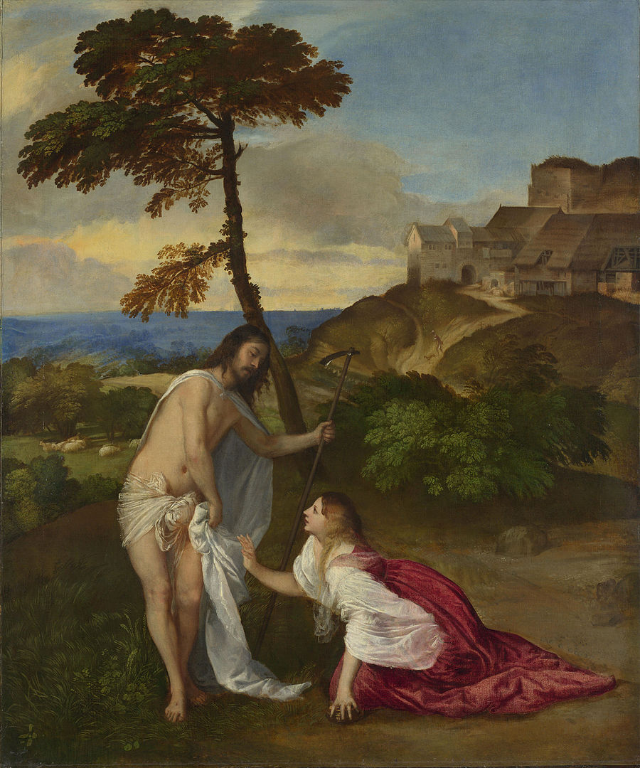

Titian, Resurrection (Noli Me Tangere), c.1514, National Gallery, London.
(NG270), digital image © National Gallery released under Creative Commons CC-BY-NC-ND, https://www.nationalgallery.org.uk/paintings/titian-noli-me-tangere
Read today’s Scripture
John 20. 1-18 – The Resurrection of Jesus and Jesus appears to Mary Magdalene.

Opening meditation
On this day Jesus says to us:
Blessed are you for sharing
this heart-breaking, earth-quaking,
mind-shaking, life-making,
miracle with me.

Meditation on the painting
Titian paints Christ as Mary Magdalene saw him. We are looking at Jesus through the eyes of faith. This encounter is as much about love as it is about landscape, and our witness is one of the few people to whom Christ revealed himself after the resurrection and before the ascension.

Here is Jesus risen from the dead, explaining to Mary Magdalene what has happened to him and why she cannot touch him. The title Noli me tangere in English ‘Do not touch me’ (or sometimes translated as do not ‘hold’ or ‘cling’ to me), comes from John 20.17. Here Jesus says that he’s still travelling to his Father. But before he ascends, Christ has an important request to make in this garden. He is about to commission Mary Magdalene to bring the Good News to the apostles and disciples. She is to be the apostle to the apostles.

Mary Magdalene has been waiting for Jesus and when told by two angels that he’s no longer in the tomb, she begins her search. To say that she is awestruck when she meets someone she believes to be a gardener is an understatement. This gardener complete with hoe and originally, a rustic hat turns out to be Christ himself. Instinctively Mary Magdalene wants to touch him to see if he is real, but she is forbidden by Jesus. In this moment, she bridges the divide between earth and heaven. Kneeling in her carnal red clothing, left hand still clutching the alabaster jar but focusing entirely on Jesus’ face, Mary Magdalene learns a new type of love.

For Titian, art was a multi-sensory experience. To see was at once to hear, to smell, to taste, and to touch, so this painting about the act of not touching combines the biblical role of the characters with the artist’s role of revelation. Christ and Mary Magdalene each brings to life what others cannot see – love and faith, transformation and renewal.
Christ is busy, but he is not in a hurry. Soon, he must ascend to heaven and in this interpretation, he’s still wearing his tomb shrouds, creating a barrier between him and Mary Magdalene. Yet in John’s Gospel, we read that he had laid his clothes aside as he rose. Nevertheless, he is preparing the way to send the Holy Spirit to his followers and he does not want them to cling to his physical presence. So, Christ is just passing by with a dance directed towards us and not to Mary Magdalene. Titian invites us to turn and face the Lord, to recognise him and to share in the joy of his resurrection. Behind Christ is a flock of sheep, a reminder of his followers then and now.
Mary Magdalene leans towards him diagonally, but her closeness to the ground shows that she is still strongly-rooted in the physical world. Christ, in contrast, is standing in front of the tree, symbolising his closeness to God in heaven. These two figures provide harmony and balance: Mary Magdalene's body is an arc and the line of her body continues up into the tree. The arc of Christ's body flows over into the curve of the rocks to our right: their contours meet in the middle. This meeting is the grace of revelation.

Questions for reflection
Where would you place yourself in this painting?
What strikes you about this Scripture text and painting most?
What is God saying to you today?

Closing Prayer
End with a prayer of your choice, or with the Our Father, Hail Mary and the Glory Be.
Amen.

EASTER MONDAY

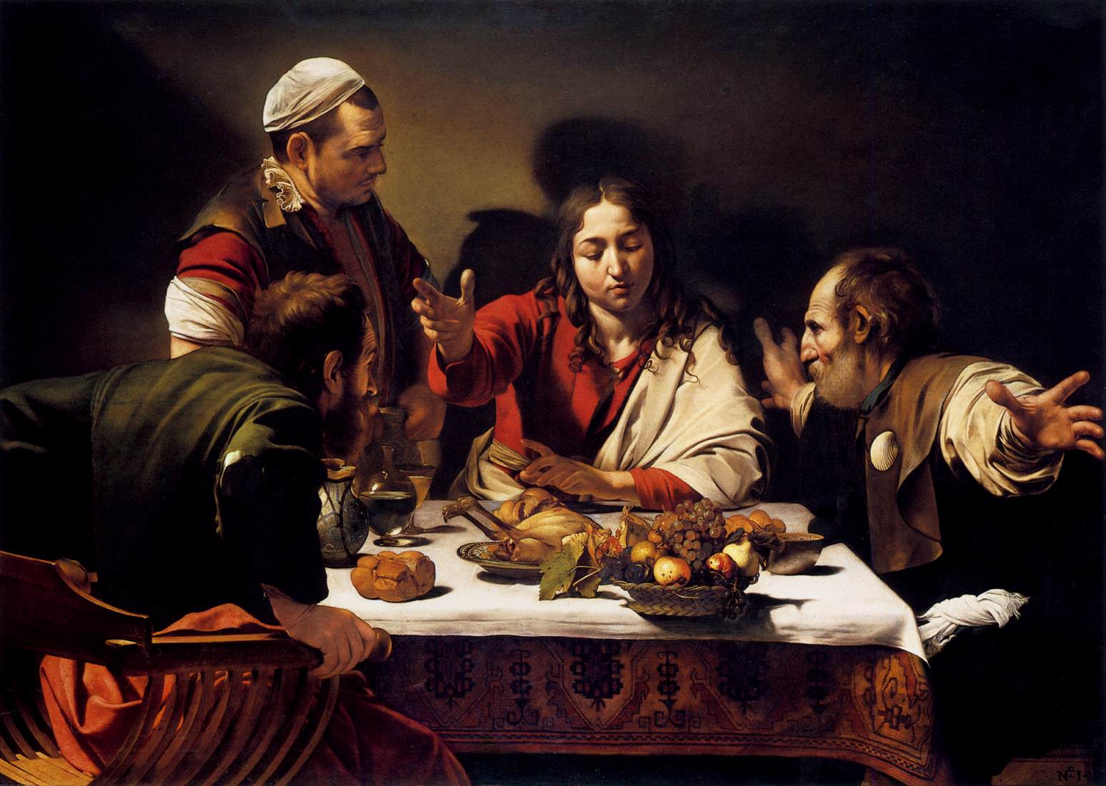

Michelangelo Merisi da Caravaggio, The Supper at Emmaus, 1601, National Gallery (NG172), digital image © National Gallery released under Creative Commons CC-BY-NC-ND, nationalgallery.org.uk
https://www.wga.hu/index1.html
Used with kind permission from the © Web Gallery of Art.

Read today’s Scripture
Luke 24. 13-35 – The Road to Emmaus

Opening meditation
They walked and talked but did not see.
They welcomed the stranger in sorrow and doubt.
They felt the Scriptures burn into their hearts
but only when they sat down to eat -
did they see Jesus bless bread and man.

Meditation on the painting
Since it is only in the eucharist that Christ reveals himself both physically and spiritually, this painting becomes timeless. Any viewer or believer in any age is welcome to the table of Christ. Caravaggio offers us the gift of salvation.

Caravaggio first painted the Supper at Emmaus in 1601, and then painted a second quite different version in 1606, which hangs in the Pinocoteca in Milan. He follows Luke’s description of a Greek symposium meal, in which the artist places Christ at the centre and the disciples on either side. Caravaggio created a large space between the two disciples that enables us to see and relate to Christ directly, rather than via the disciples. This allows us to participate in this symbolic meal. The disciple on Jesus’ right is Cleopas and an unnamed disciple on his left wears the pilgrim’s symbolic scallop shell. The disciples were not on a pilgrimage, because pilgrimages only became popular from the 4th century AD. Caravaggio probably saw the symbol as part of the Counter-Reformation revivals in mediaeval religious devotion.

Despite the absence of candles we see colours range from the darkest to the lightest through the skill of shifting abruptly between one tone and another. This chiaroscuro technique ensures that the light is at the service of the whole picture and therefore, the whole meaning. This scene feels deceptively real, rather than imagined. Its tension and force lie in the illusion that we are participators in this miraculous event. From the varied gestures and the jacket sleeve united in their emergence from the painting, to the symbolic fruit bowl about to topple over, Caravaggio shows us the difference between telling and showing.

Caravaggio does not depict Christ with obvious credentials except that of his red and white cloak, symbolising the triumphant resurrection. We cannot see any nail marks in his hands, nor a wound in his side, or any facial features that would distinguish him from his companions. He is recognised in his gesture alone. The innkeeper is static and bewildered. He does not recognise the blessing symbol or understand the disciples’ reactions. Does he represent the faithless who fail to recognise this Messiah, hence not removing his cap?

Caravaggio’s bread is already broken, but in Luke 24.30 Jesus ‘took bread, blessed and broke it, and gave it to them.’ This Jesus is focused more on the blessing, as if to prolong the sublime gesture and to heighten the dramatic and divine intervention. The disciples are understandably overcome with shock, emphasised by having one disciple grasping the sides of his Savonarola chair while the other counterbalances this with outstretched arms bridging darkness and light, our world and the picture’s. This disciple’s arms may symbolise further, the shape of the cross. So, might he be Peter who was also crucified? Caravaggio was reminding us that the Christian sacramental meal occurs because of Christ’s crucifixion.
Caravaggio is also demonstrating that time is inclusive. The breaking of the bread, its blessing, the disciples’ reaction and the cross symbol are happening simultaneously on the canvas. These disciples are the conductors of this astonishing revelation.

Questions for reflection
Where would you place yourself in this painting?
What strikes you about this Scripture text and painting most?
What is God saying to you today?

Closing Prayer
End with a prayer of your choice, or with the Our Father, Hail Mary and the Glory Be.
Amen.

SUNDAY AFTER THE RESURRECTION

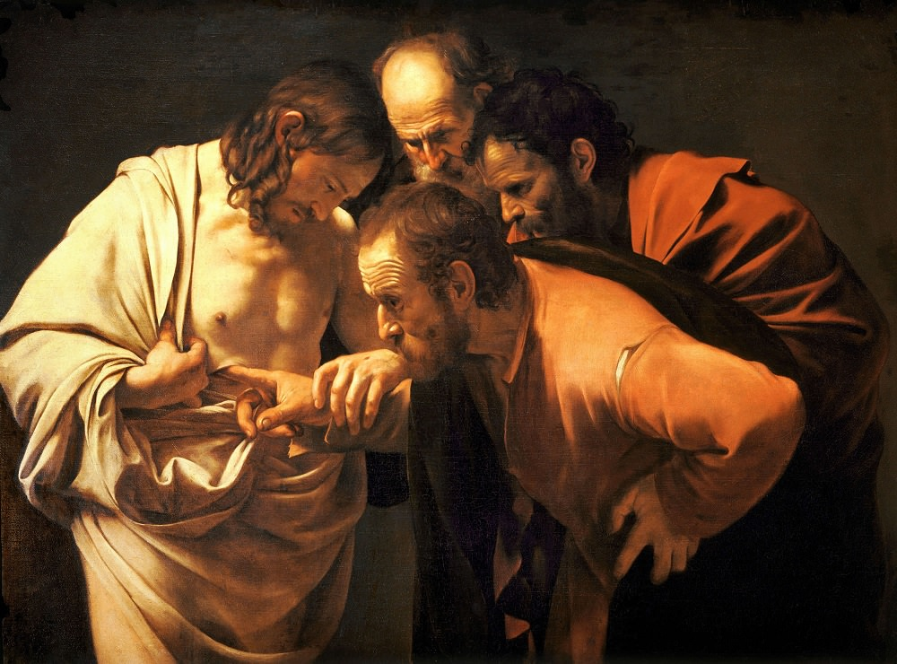

The Incredulity of St. Thomas, 1601-02 – Caravaggio.
Sanssouci, Potsdam, Germany.
https://www.wga.hu/html/c/caravagg/06/34thomas.html
Used with kind permission from the © Web Gallery of Art.

Read today’s Scripture
John 20. 24-29 – Jesus and Thomas

Opening meditation
Loving Lord who shatters tombs,
shatter any doubts in me.
You have risen from the dead
and blessed the world with hope and truth.
Your grace is all I need.

Meditation on the painting
Here, as in the last painting, Christ doesn’t have a halo. Caravaggio does this to emphasise his humanity, not his divinity as the risen Lord. All the post-resurrection experiences with Christ were real, visible, and accessible through the bodily senses. Christ is not a spirit or ghost, but a complete human being who meets, greets, talks, walks, fishes, eats and blesses people after he has died. Caravaggio's skill lies in making this a reality. Look at Christ’s anatomical perfection compared with the disciples’ bulk; the elaborate folds of Christ’s shrouded garment (birth and death in one body); watch out for the ripped seam on Thomas's faded clothes; his dirty fingernails to stress his poverty and Christ’s empathy with the poor.
Look at the disciple crouching to our right. It’s probably John, the beloved disciple. Dressed in a sacrificial red robe, this is the same John in another Caravaggio painting. Caravaggio knew that John would be interested in seeing the wound in Jesus’ side. This wound is near Jesus’ chest where John had lovingly placed his head at the last supper in John 13. Now see the Gothic archway formed by the outline of the four figures compacted into a tenebristic background. The disciple at the head of this cluster is St. Peter. He’s at the top because he became head of the Church. We also observe that the top of Christ's head is largely in shadow, since he is the person who is least knowable to us humans, the viewers.

Within the shadows of Christ’s face, Caravaggio has tucked Jesus’s hair behind his ear so that we also can see his face, and we see Christ gazing at his own body. It’s very rare in art to see a painting where Jesus is looking at himself. This is a moment of self-revelation on Christ’s part and of revelation of self on the disciples’ part. To realise the unrealisable, to bring this miracle within the immediate grasp and understanding of everyone is the genius of both John’s Gospel story and of Caravaggio. We weren’t there, but we can be sure from this painting and its supporting text, that the resurrection was, and is, real.
To want to see Jesus again is not about doubt, as Thomas has, consistently been accused, but about relationship. Thomas only asked for what the other disciples had already experienced. When it came to it, in John’s Gospel, he didn’t actually need to touch Jesus. He only does this here, so that we know which disciple he is. Thomas’ declaration of faith is unique. No other disciple in any of the Gospels expresses their faith in Christ with the same weight. When Simon Peter says ‘You are the messiah, the Son of the living God’, it isn’t the same as Thomas saying ‘My Lord and my God’. In the Greek, this is more radical, more personal and it connects the beginning of John’s Gospel with its end because ‘The Word became flesh and dwelt amongst us’ happens again right now.

It‘s no accident that there are far fewer paintings of the resurrection than of the crucifixion, since the Gospels barely describe the resurrection in any detail, they just say it happened.
Is it any wonder therefore, that here the disciples’ have appalling manners, gawping at Jesus without restraint or sense of decorum. They’re in no hurry to leave, or to let Jesus get on with his busy week, because quite simply, the resurrection is no ordinary event.
Questions for reflection
Where would you place yourself in this painting?
What strikes you about this Scripture text and painting most?
What is God saying to you today?

Closing Prayer
End with a prayer of your choice, or with the Our Father, Hail Mary and the Glory Be.
Amen.

The God who Speaks: The Year of the Word
The God who Speaks is an exciting initiative between Bible Society and the Catholic Church which focuses on celebrating, living and sharing God’s word throughout England and Wales.

Our Vision
Scripture is foundational to the life of the Catholic Church and so we want to enable deeper Scriptural engagement in every diocese.
We want to create new and renewed encounters with Christ through the Scriptures.
We want to achieve transformation in the faith and life of our Church and in the public arena through evangelisation, education, creative arts and social action.

Our Themes
a) Celebrating God’s Word – enriching our worshipping and spiritual community.
b) Living God’s Word – enriching our social action and outreach.
c) Sharing God’s Word – enriching our formation, proclamation and evangelisation.
The Bible inspires learning, culture, art, music and literature. It enables science and faith to build up mutual understanding through dialogue. It challenges technology and social media to open up new ways to encounter and share Christ in the world. The Bible can break down barriers and build strong communities through working together for the common good.

For more information about this Scripture initiative go to godwhospeaks.uk

