Most Reverend Paolino Lukudu Loro, Archbishop of Juba
C/O Ms Jane Andanje
CAFOD Representative, Juba

By Email: jandanje@lan.cafod.com
Thursday 19th December 2013

Dear Archbishop Lukudu Loro
I am writing to you on behalf of the Bishops of England Wales to assure you of our prayers and good wishes in this time of trouble in South Sudan.
With you we worry that political tensions could be manipulated to become inter-tribal violence and we are heartened to see that you and the other religious leaders have promptly raised your voices in an effort to broker a non-violent solution to the present political divisions.
As we approach the feast of Christmas, we pray with you that you and all citizens of Juba and South Sudan will be able to celebrate it safely in peace and that all those who have been negatively affected by these last days of violence will receive the help that they need to return home and pick up their lives.
We also pray that you Church leaders will continue to have the wisdom and the courage to speak as the conscience of South Sudan and to act as brokers for peace.
With every best wish to you and all the other Church leaders for a happy holy and peaceful Christmas,
Yours in Christ
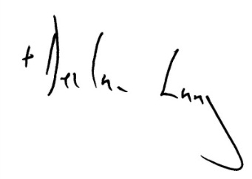
+Declan Lang
Bishop of Clifton and Chairman,
Department of International Affairs, Catholic Bishops’ Conference of England and Wales.

