The Year of Faith begins on October 11th 2012 and ends on 24th November 2013.
This Little Way Week assembly resource has been designed to help introduce the Year of Faith.
Forgiveness
Assertiveness
Idealism
Tolerance
Happiness


Assembly
Monday 7th October 2012
Visual resources (included at the end of this resource for print out)
- Picture of St Thérèse of Lisieux
- Flowers (petals)
- FAITH cards
- Petal cards

Introduction

Ask the children, ‘Have you ever been asked to do a little job for your parents?’ Share examples. If there is a limited response share some of the following:
- Collect a tea towel from the kitchen so mum can clear up a spill
- Place the cutlery on the table
- Put some clothes in the wash basket
Use one of the little jobs suggested by a child or from the list above and expand to show how big the overall job is.

For example:-

- the little job is to place the washing in the basket but your parents will
  - shop for the washing powder
  - sort the clothes into piles for washing
  - place in the machine
  - select the wash cycle
  - empty the machine and hang clothes on the line
  - collect them in again
  - iron them
  - fold or hang them
  - Ready for you to wear again
What a BIG job!

Ask the children, ‘Which job would you rather do each day, the little job or the big job?’

Main

Share with the children the picture of St Thérèse of Lisieux.
Explain simply who St Thérèse of Lisieux is:-
St Thérèse of Lisieux
St Thérèse lived over a hundred years ago. She lived a very simple life and at the age of 15 she became a nun. Whilst living as a nun St Thérèse came to realise how small and insignificant she was. She began to feel the limitations of her efforts. She felt too small to really be able to accomplish anything big. It was then that she understood that it was her littleness that she must lean on to ask for God’s help. Her smallness became a reason for joy rather than disappointment.
St Thérèse, in her quest for sanctity (a holy life) appreciated the importance of doing little things. It was not always necessary to do big ‘heroic acts’. To express her love of God she wrote:
"Love proves itself by deeds, so how am I to show my love? The only way I can prove my love is by scattering flowers and these flowers are every little sacrifice, every glance and word, and the doing of the least actions for love." (Story of a Soul)
Refer to the picture of St Thérèse and ask the children ‘What do you notice is in the picture?’
- Jesus
- Flowers
- A child
Referring to the above responses, share with the children that St Thérèse is also known as St Thérèse of the Child Jesus and ‘The Little Flower’.
Just like St Thérèse said in the quote above, by doing little things you can still show love. St Thérèse saw herself like a little wild flower in the garden (refer to flowers on display). She saw herself as someone who was growing, often unnoticed by passers-by, but nether-the-less she sought to love God and give joy to those around her. St Thérèse knew that God was calling her to be herself and do everything with love – even if it was only a something small. This became known as her ‘little way’.
Focus
Arrange for 5 children volunteers to stand at the front holding the FAITH cards.
Until 24 November we are celebrating the Year of Faith and throughout the past year we have been thinking about our faith and how we live our faith. Therefore, to continue our celebrations of the Year of Faith, we are all going to try and do at least 5 little things this week that express our love of God and each other.
Each day we are going to look at a different virtue (a good habit) to support us in our ‘Little ways’. Turn over each FAITH card to reveal each word with its explanation. Simply introduce each one.
Today we are going to focus on Forgiveness (you might wish to also incorporate here reading out Wednesday Word’s scriptural thought for the day resource – The Good Samaritan – forgive your neighbour). As we start our journey we need to think about those people who may have hurt you in the past and you still haven’t quite forgiven. Think too about someone you might need to say sorry to. Take a moment to think…
Let’s remember St Thérèse’s little way, like scattering little rose petals (you might wish to scatter some petals at this point). What little thing can you do today to show Forgiveness?
(Included in this resource is a petal template or a flower with 5 petals.)
Each of you will be given 5 petals. Each day we would like you to write down the little thing you did to show each virtue. These will then be added to a display in your classroom, to form a big flower, showing how the little things can be a big expression of your love of God and of each other.
Conclusion
Briefly remind the children of the plans for our ‘Little Way Week’ and maybe encourage the children by explaining how you plan to show forgiveness today.
Let us put our hands together to finish with a prayer to St Thérèse asking her to help us on our journey this week:
Prayer to St Thérèse:
O Little Thérèse of the Child Jesus,
Please pick for me a rose from the heavenly garden
And send it to me as a message of love.

O Little Flower of Jesus, ask God, today, to grant
The favours I now place with confidence in your hands...
(Mention in your mind and heart the specific request)

St. Thérèse, help me to always believe, as you did, in God's great love for me,
So that I might imitate your "Little Way" each day.
Amen.

Daily Input
Start each day either in an assembly or in class, introducing each good habit and provide each child with another petal.
Tuesday 8th October
Assertiveness
Look at the faith card for assertiveness and share the meaning with the children. Read Wednesday Word’s scriptural thought for the day and ask the children ‘How was Mary being assertive?’
Remind the children that St Thérèse was very confident in her little way and she was known to have said ‘my way is all confidence and love’. Today, what will be your little way of showing your love of God by being assertive?
- Will you listen to the teacher even when others are trying to distract you?
- How will you show your assertiveness on the playground?

Provide the children with their second petal (this could be done towards the end of the day). Encourage the children to draw or write briefly about how they have been assertive today.
Finish with a prayer to St Thérèse

Wednesday 9th October
Idealism
Look at the faith card for idealism and share the meaning with the children. Read Wednesday Word’s scriptural thought for the day and ask the children ‘In an ideal world, how would Jesus like us to behave?’
Refer to the picture of St Thérèse. St Thérèse was also known as the Little Flower’ because like the little flowers in the garden, St Thérèse also felt small but realised how her little way can spread such joy. By having ideals and doing what you know is right, you too can spread joy. Today, what will be your little way of showing your love of God by being idealistic?
- Will you stop playing a game, to help someone who is hurt?
- How will you try and make a difference today?

Provide the children with their third petal. Encourage the children to draw or write briefly about how their behaviour reflected idealism.
Finish with a prayer to St Thérèse

Thursday 10th October
Tolerance
Look at the faith card for the tolerance and share the meaning with the children. Read Wednesday Word’s scriptural thought for the day and ask the children ‘When someone knocks on your door, how tolerant are you of them?’
St Thérèse, whilst living as a nun with lots of other older nuns often felt like she wasn’t doing much. She felt small and limited in her actions. However, she learned to be more tolerant of herself and accepted the fact that she was small (and young). She realised she was important in her own special ‘little way.’ Today, what will be your little way of showing your love of God by being tolerant?
- At home how will you be more tolerant of your brother or sister?
- How can you try and be more patient with your parents?

Provide the children with their fourth petal. Encourage the children to draw or write briefly about how they have been more tolerant of others.
Finish with a prayer to St Thérèse
Friday 11th October
Happiness
Read Wednesday Word’s scriptural thought for the day and ask the children ‘How has your faith grown this week?’
St Thérèse applied herself to practise little virtues (good habits) as she didn’t feel she could perform big ones. All this week you have been virtuous in your little behaviours each day and our display is showing all our efforts (refer to flower display nearly complete with petals).
Ask the children ‘How did you feel when you were doing a little something that you knew was virtuous – a good habit?’ After they have responded ask again ‘How do you think your virtuous behaviour made others feel?’
Look at the faith card happiness and share the meaning with the children. Happiness isn’t a virtue but it is a result of virtuous behaviour. Your responses demonstrate how happy it has made you, God and others.
Referring to the flower display – just like the flowers St Thérèse saw herself as, you have all, in your little way, been a flower this week, spreading happiness to everyone. On this last petal, draw or write how your faith this week has made you happy. Add these last petals to the display, reading them aloud as they are arranged.
Finish with a prayer to St Thérèse
Born: 2nd January 1873. Died: 30th September 1897. Feast Day: 1st October
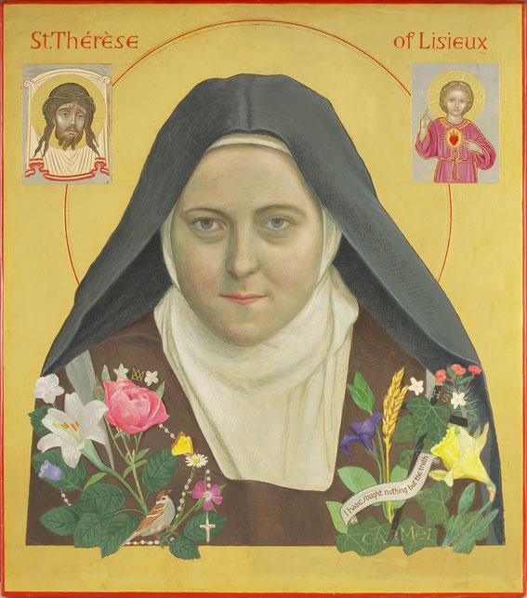
F
A
I
T
H



