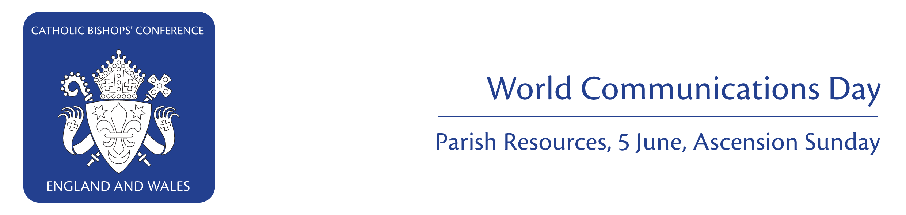
Request from Bishop George Stack

Contents
Dear Father, April 2011
World Communications Day is on 5 June, the Feast of the Ascension. The Church has asked that we keep communications professionals in our prayers on this day, that they be witnesses to the truth and offer hope. Please ask your parishioners on 5 June to pray for and give generously to the work of the Catholic Communications Network (CCN), the media office of the Catholic Bishops’ Conference of England and Wales.
The CCN provides support for the bishops of England and Wales and the Church more widely in promoting the Gospel through the media. The office is the central point for media enquiries; it plays a key role in developing the public profile of the Church and was responsible for the Church’s media co-ordination of the Papal Visit to England and Scotland last year. The media's reporting of the Visit was assisted and enhanced by a variety of CCN resources. These included the Papal Visit website which attracted record numbers of visitors in the millions and hosted the biggest ever web stream in the UK; social media; fact sheets for the media; and press kits for over 3,000 accredited journalists. CCN also collaborated with national newspapers and magazines; trained spokespeople and acted as a hub for media interviews.

Many other stories on religious issues which have hit the headlines over the past year have been handled by the CCN: whether it be to explain the Church’s teachings or by providing suitable Catholic spokespeople to appear on national television. In this year’s World Communications Day message the Holy Father invites us to reflect on ways in which we can witness to the Gospel in the digital era. The theme is ‘Truth, Proclamation and Authenticity of Life in the Digital Age’.

This year we would be grateful if the collection proceeds from your parish could be sent to the office of the Catholic Trust for England & Wales. Details are on the collection form below. Please note, the Catholic Trust for England & Wales is reviewing its Gift Aid procedures and will not be collecting Gift Aid on the World Communications Day collection this year. Resources such as a newsletter insert, liturgical materials and collection form are below. I am grateful for your support in promoting the work of the CCN for, and on behalf of, the Catholic Bishops’ Conference.

With every good wish

Yours in Christ

- Request from Bishop George Stack
- Parish newsletter insert
- Images for parish newsletters
- Parish website text

- Homily notes
- Bidding prayers
- Collection form

Bishop George Stack
Auxiliary Bishop for the Diocese of Westminster, Media Bishop


Parish Newsletter Insert

Images for Parish Newsletters

The Flickr website has photos of Catholic life and events which you can download free for your parish newsletter and website to go with the text above. You are welcome to use these more widely in your parish resources: www.flickr.com/photos/catholicism/. Please credit: © Mazur/catholicchurch.org.uk
World Communications Day, 5 June, Ascension Sunday
On World Communications Day we pray for communications professionals. The theme this year is ‘Truth, Proclamation and Authenticity of Life in the Digital Age’. The Catholic Communications Network (CCN) provides support for the bishops of England and Wales and the Church more widely in promoting the Gospel through the media, and was responsible for the Church’s media co-ordination of the Papal Visit. There will be a second collection to support CCN’s work. Please help the CCN to promote the Good News through the media, by your prayers and generosity.
www.catholicchurch.org.uk/world-comms-2011

World Communications Day: Parish Resources
World Communications Day, 5 June, Ascension Sunday
On World Communications Day we pray for communications professionals. The theme this year is ‘Truth, Proclamation and Authenticity of Life in the Digital Age’. The Catholic Communications Network (CCN) provides support for the bishops of England and Wales and the Church more widely in promoting the Gospel through the media, and was responsible for the Church’s media co-ordination of the Papal Visit. There will be a second collection to support CCN’s work. Please help the CCN to promote the Good News through the media, by your prayers and generosity.
www.catholicchurch.org.uk/world-comms-2011
‘Messages of Faith’ on Facebook, 5 June
Post ‘Messages of Faith’ on your Facebook wall in the week leading up to 5 June, World Communications Day. Share with friends: photos, videos, words which express the Gospel message: a moment in prayer, an inspiring song, a sacred place, a pilgrimage journey, words of encouragement etc. Inspired by the Papal Visit to the UK and the Pope’s World Communications Day message, Catholics in the UK are invited to respond to the Pope’s invitation to proclaim the Gospel message through the internet. The idea is being passed on through the 10,000 active users of www.facebook.com/papalvisit. To join in, upload Messages of Faith to your Facebook profile in the week leading up to 5 June.

www.catholicchurch.org.uk/world-comms-2011

Parish Website Text

Homily Notes - World Communications Day, 5 June, Ascension Sunday

After the historic visit of Pope Benedict XVI to the United Kingdom a national newspaper reflected on why the visit had been such a resounding success.
It came to a very simple conclusion:
Pope Benedict’s visit was so successful because of what he said and the way in which he said it.
He spoke simply but with authority about his faith.
On this Ascension Day we hear of Jesus speaking of his own authority.
He says in the Gospel:
‘All authority in heaven and on earth has been given to me.’
Authority can be used in many ways:
A dictator has authority, he can impose his will on others.
But there is another kind of authority.
There is the moral authority of a Mother Teresa or Archbishop Oscar Romero who command attention because of the integrity of their lives.
The word authority is in each of the three readings at Mass today. It has its roots in the Latin words auctor and augere which means to broaden or to increase.
That is the authority of Jesus. He is the one who lifts us up to an ever wider and broader view of life.
St Paul writes to the Ephesians:
‘May he enlighten the eyes of your minds so that you can see what hope his call holds for you’.
To be a disciple of Jesus is to allow him to lead us away from all that is narrow, small-minded and confining. Jesus will constantly widen our horizons - if we allow him to.
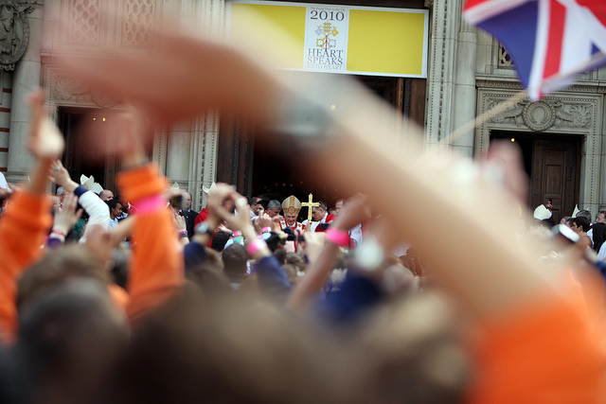
Today, Ascension Day, is also World Communications Day.
And we hear the words of Christ to us:
to ‘teach all the commands’ he has given to us.
Jesus places his authority into our hands.
To teach as he has taught.
But we will only communicate Christ’s word effectively if we have first allowed that word to dwell in us.

If we have allowed God’s word to stretch and broaden us then we too will teach with authority.
It is only then that our communication of the Word will be open and transformative.
In his message for World Communications Day this year Pope Benedict said:
‘The proclamation of the Gospel requires a communication which is at once respectful and sensitive, which stimulates the heart and moves the conscience; one which reflects the example of the risen Jesus.’
The challenge to us on Ascension Day is to open ourselves to the liberating Word of God and so to communicate that word with authority.

Fr Michael McAndrew, Clifton Diocese
Images
© Mazur/www.thepapalvisit.org.uk,
copyright © 2011 iStockphoto LP.
Bidding Prayers - World Communications Day, 5 June, Ascension Sunday

Priest
The promise of Christ is that he is with us always. In our Eucharist he makes himself present through the proclaimed Word and the Communion we share.
Our mission is to communicate the presence of Christ in our lives. Let us turn to him, sure in the knowledge of Christ who is with us, that it is he who inspires and answers our prayers.

Reader
We pray for the Church; that all who follow Christ may continue to proclaim the Good News of Jesus Christ to the world, and may teach with authority the Word of God.
Reader
We pray for our parishes and local communities; that we may show by example the power of God’s presence in our lives and so lead others to Christ.
Reader
We pray for those who are seeking faith;
that they may open their hearts and minds to the message of the Church and the saving words of Our Lord.
Reader
We pray for those who communicate the Gospel; that they may use wisely all available technology so that the Word of God may enter people’s hearts and take root in their lives.
Reader
We pray for our young people; that in the midst of the noise of their lives they may hear the still small voice of calm leading them to the wisdom of God.
Reader
We pray for those who make themselves deaf to words of healing and forgiveness;
that they may turn to the consoling and compassionate words that lead to true life.
Reader
We pray for those who are sick, those who are in need, and those who are dying; that words of hope and comfort may transform their lives into journeys of faith, and God’s healing power can be part of their lives.
Reader
We turn to Our Lady, who bore the Word made Flesh in her womb, that we may bring to birth the Word of God on our lives. Hail Mary…..
Priest
God our Father, we give thanks for hearing our prayers.
May we joyfully give witness to the promises of our baptism and the Risen Lord in our lives, so that others may come to know and love you. We make these prayers through Christ our Lord.

Collection Form - World Communications Day, 5 June 2011

Parish Name
Diocese
Total Amount of Collection £
Please make cheque(s) payable to Catholic Trust for England & Wales (CaTEW)

Forward this summary along with cheques(s) to:

Catholic Trust for England & Wales
39 Eccleston Square
London
SW1V 1BX

Please note, the Catholic Trust for England & Wales is reviewing its Gift Aid procedures and will not be collecting Gift Aid on the World Communications Day collection this year.

Catholic Trust for England and Wales
39 Eccleston Square, London SW1V 1BX
Company no. 4734592 registered charity number 1097482

