RABBIT PROOF FENCE
Australia, 2001, Philip Noyce
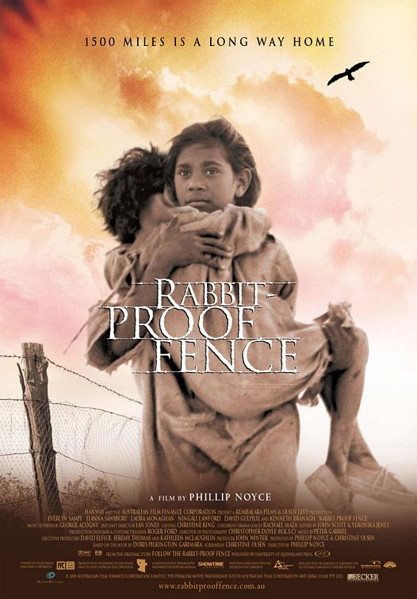

Rabbit Proof Fence is a story of what is now called the Stolen Generation: many aborigines were forcibly taken from their families to be trained as servants or tradesmen. White families then adopted them. It is based on the book by Doris Pilkington.
In 1930, three young girls escaped from a settlement presided over by a government official who had 'protective' rights over all aborigines in Western Australia. They made their way home during a months' long trek along the fence erected to keep out rabbits. Two of them, by this time in their 80s, appear at the end of the film. They add some heart-rending detail of how their story repeated itself with the next generation.
Mr Neville, the official 'Protector' inhabits a world of clear (and unquestioned) principles. These 'objective' criteria included such policies as ‘the lighter the skin, the more clever the child’. He alone had the authority to determine the intelligence of each child. He quotes mathematical statistics to explain how their aboriginal blood can be 'bred out of them'. This is the logic of supremacy. Mr Neville is played by Kenneth Branagh with an earnest righteousness that manifests itself in an unswerving paternalism. The children nickname 'Mr Devil'. He does appreciate that he does not understand the aboriginal mind. They are a puzzle. 'They may have neolithic tools but they do not have neolithic minds'. "The natives must be helped.'
Phillip Noyce directed a short feature in 1977 on aborigines who live on the edges of Australian towns, Backroads. After a successful career in Australian film and television (Newsfront, Heatwave, Cowra Breakout, Bodyline and Dead Calm), he went to Hollywood. His American movies include Patriot Games, Clear and Present Danger, The Saint and The Bone Collector. He then returned home to make Rabbit Proof Fence and a new version of Graham Greene’s The Quiet American with Michael Caine and Brendan Fraser.
An apology from the Australian government to the Stolen Generation is an issue that has dogged Australian society and politics since the early 90s. It is an echo of the differences between the past protectors who knew they were doing the right thing and the people whose lives were often destroyed as children were separated from parents and families. Rabbit Proof Fence is a proof for immigrants to Australia since 1788 that they need to express their sorrow at what happened to the indigenous people.

