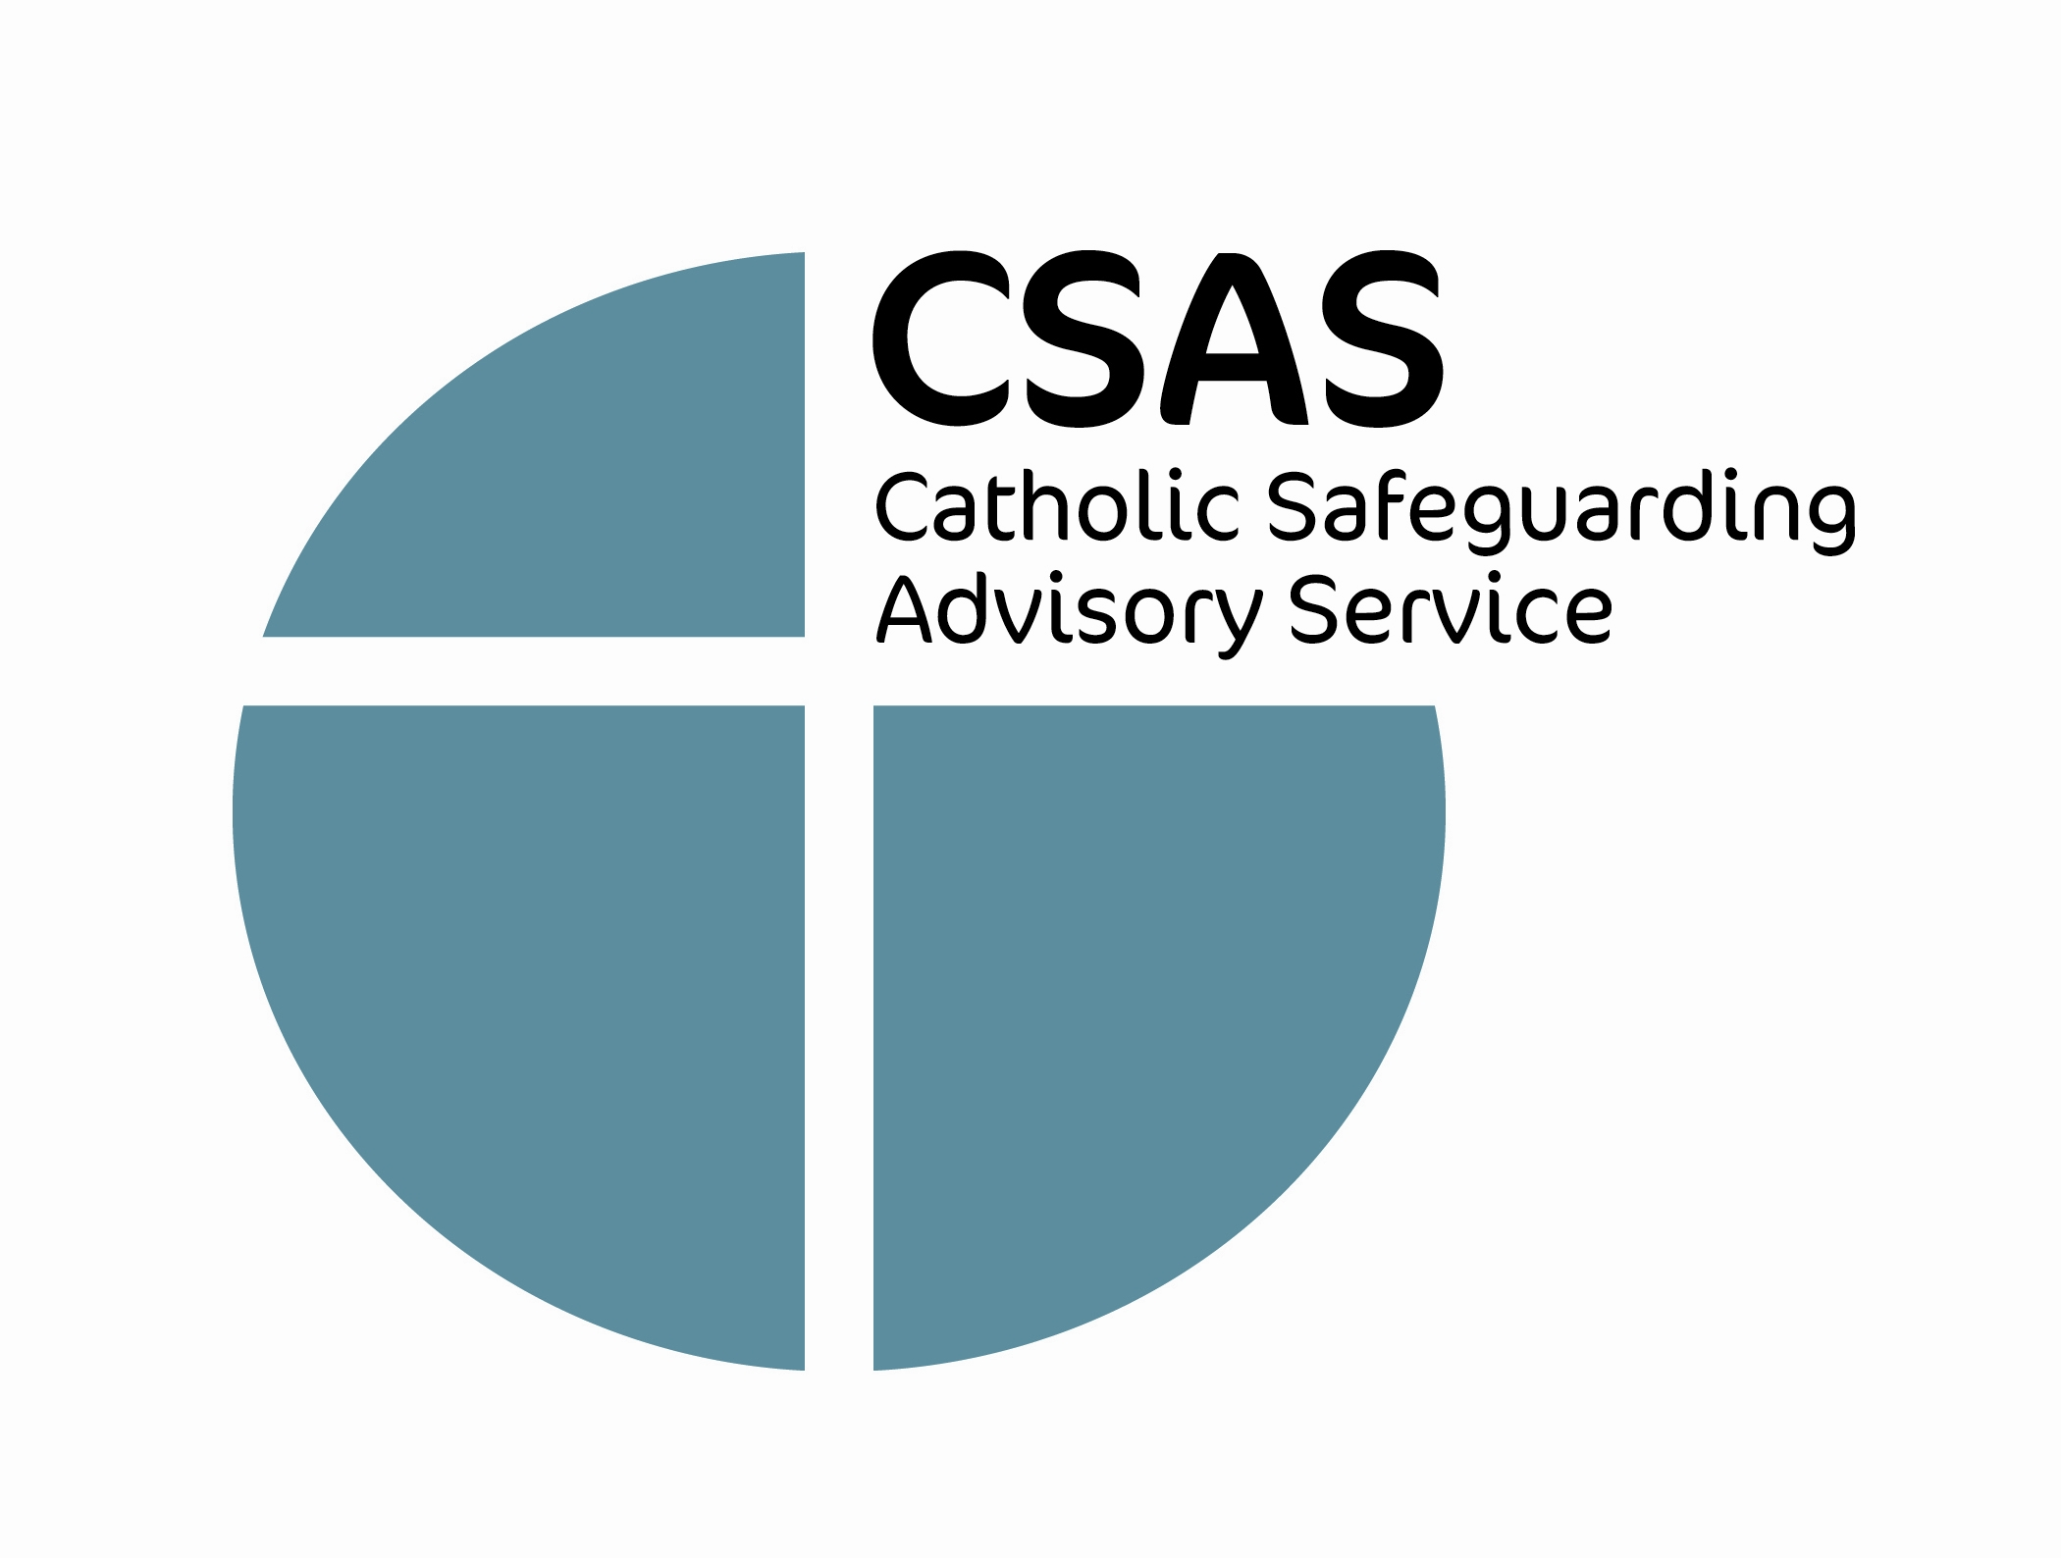
Job Description and Person Specification

Job Title: Team Secretary

Date: September 2008

Reports to: PA to the Director

Job Purpose:
Under the direction and supervision of the PA to the Director, the post holder will provide an effective and efficient secretarial and administrative service to all members of CSAS .

The post holder will also provide assistance to the National Safeguarding Systems adviser in relation to CRB Registered Body responsibilities and national database functions.

Main Responsibilities
- To assist the PA to the Director in developing and maintaining an effective and efficient administrative and secretarial service at CSAS, with sensitivity to issues of quality and diversity.

- To provide a responsive, sensitive and accurate reception and message taking service to CSAS.

- To provide high-quality secretarial support to CSAS in line with agreed standards and procedures.

- To provide support for meetings including minute taking as directed by the PA to the Director/ National Safeguarding Systems Adviser

- To provide an efficient administrative service to CSAS, including photocopying, filing and collation of documents, convening meetings and minute taking.

- To assist in the production of policy documents including typing, formatting and distribution as required.

- To handle in-coming and out-going post in line with agreed standards and procedures.

- To coordinate and organise mailings for example policy updates and Reports.

- To deal with telephone callers and visitors to CSAS in an approachable, sensitive and professional manner.

- To prepare meeting rooms, including refreshments, in line with agreed standards.

- To provide office cover in the absence of the PA to the Director/National Safeguarding Systems Adviser.

- To assist with the processing of confidential data relating to Criminal Records Bureau Disclosures/ISA applications.

- To assist the National Safeguarding Systems Adviser in the effective development and operation of business support systems.

- To assist the National Safeguarding Systems Adviser in the operation of financial processes.

- To assist in collating and presenting Management Information regarding all aspects of safeguarding work in the Dioceses and Religious Congregations.

- To assist in the maintenance of systems relating to CRB, ISA and Finance.

- To assist in the operation of audit and other evaluation systems regarding the operation and effectiveness of safeguarding policies, procedures, training etc.

- To provide advice to Dioceses and Religious concerning the operation of CRB, ISA, Audit and Management Information systems within the role’s remit.

- To undertake other duties as requested by the Director or by the General Secretary through the Director.

Person Specification

Team Secretary

 | Essential Criteria | Desirable Criteria
Experience | - Excellent administrative and secretarial experience.
Knowledge | - An understanding of security and confidentiality requirements of CSAS.  - Computer literacy in the use of Word, Excel spreadsheets, Access Database and Microsoft Outlook applications. | - An understanding of the Catholic Church, its teaching and structures.
Skills/Abilities | - Flexibility and an interest in/willingness to build on existing skills.  - The ability to respond sensitively to people at all levels.  - The ability to contribute fully to the development of CSAS and to be an effective team player.  - Willingness and ability to work on own initiative and to high standards.

Personal Attributes | - An interest in and commitment to CSAS’s aims and purpose.  - Commitment to helping the Catholic Church improve its systems for safeguarding children and vulnerable adults  - Self-motivated, self-reliant, enthusiastic and team player.  - Attentive to detail, adaptable, flexible, quick to critically absorb and retain information.

Terms and Conditions
- The employer is the Catholic Bishops’ Conference of England and Wales – CaTEW is a registered charity No 1097482.

- The place of work is 43 Temple Row, Birmingham, B2 5LS

- This is a permanent contract at a salary of £17,403 pro-rata on Grade 5 of our salary scale. Actually salary for 21 hours is £10,441.80.

- There is a CaTEW personal pension plan scheme which CaTEW will match contributions up to a maximum of 6% of salary.

- We offer a death in service benefit which is three times the basic salary.

- Expenses and subsistence allowances are in accordance with current CaTEW scales which follow Inland Revenue no liability guidelines.

September 2008

