HOTEL RWANDA
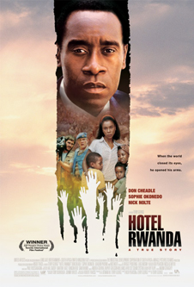
US, 2005, d. Terry George

It is probably a blessing for the commercial success of Hotel Rwanda that Don Cheadle and Sophie Okenado were nominated for acting Oscars, otherwise the film might have received very limited release. This happened with director Terry George’s moving film about IRA prisoners in the late 1970s, Some Mother’s Son. It was considered not commercial enough to warrant a promotion budget. Along with Raoul Peck’s quite similar, Sometimes in April, it offers an opportunity for a world audience to learn something about the 1994 genocide in Rwanda and learn lessons about compassion and the need for political will for help and intervention.
Shot principally in Rwanda, the film has an authentic look and feel, some of it with documentary vividness.
This is a particular focus on Paul, the manager of the Mille Collines Hotel and his helping refugees. Sometimes in April, directed by Raoul Peck is well worth seeing as a companion piece, along with Michael Caton Jones’ Shooting Dogs, also known as Beyond the Gates. It ranges far more broadly, especially with US policy and the aftermath ten years later. This is, rather, the story of an ordinary man who is asked to be more heroic than he ever imagined. His story is placed firmly in context so that we understand something of the uprising, the Hutu hatred of Tutsis (‘rebel cockroaches’), the urgings of hate radio, the slowness of the world to respond.
Don Cheadle (who can do comedy as well as con-man gangsters so well) is utterly persuasive as Paul. The audience experiences the action through complete sympathy with him. Sophie Okenedo is moving as his wife. A strong African cast gives authenticity and Nick Nolte (as UN leader) , Joaquin Phoenix (as a TV reporter) and Jean Reno (as the president of Sabena) give the film some international appeal.
It is harrowing to remember that such genocide and subsequent refugee movement could happen in the 1990s.

