CATHOLIC BISHOPS’ CONFERENCE OF ENGLAND AND WALES
Committee for Catholic Jewish Relations

Holocaust Memorial Day

27 January 2016

“Don’t Stand By”

“The Spirit of the Lord has been given to me,
For he has anointed me.
He has sent me to bring good news to the poor,
To proclaim liberty to captives
And to the blind new sight,
To set the downtrodden free,
And to proclaim a year of the Lord’s favour.”

Luke 4:16-19

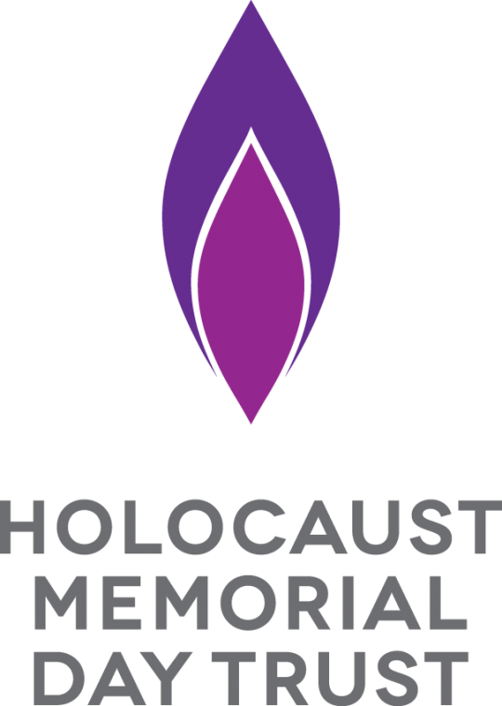
Reflection

On Wednesday, 27 January, Pope Francis visits the Jewish community in Rome at their synagogue to express solidarity with the whole House of Israel throughout the world on the anniversary of the liberation of Auschwitz in 1945.

In the United Kingdom, special events will mark Holocaust Memorial Day. This year, we are invited to reflect on the theme “Don’t Stand By”. It has been said that for evil to succeed all that is required is for good people to do nothing. Sadly, during the genocide against the Jews and others in the mid-twentieth century and in other recent genocides, too many people did stand by and look on.

Elie Wiesel, a holocaust survivor, said: “I swore never to be silent whenever and wherever human beings endure suffering and humiliation.”

On another Sunday later this year, a reading from St Luke’s Gospel will remind us about the merciful actions of the good Samaritan. He did not stand by. He took action in the face of the evil that confronted him on the Jericho road.

Pope Francis is asking us to use the Jubilee Year of Mercy to change our attitudes so that we become less judgmental and self-righteous in order to foster a spirit of understanding and mercy for others. He want us, like Jesus, to stand alongside the needy, the downtrodden and the victims of hate crime.

This Holocaust Memorial Day challenges us to remember that standing by and not taking action in the face of evil brought terrible suffering and injustice for others. The bystanders allowed genocide to happen. Let us resolve not to be bystanders but to be with Jesus in being “good news” to those who suffer, or have suffered, genocide. Let our attitudes and our actions “set the downtrodden free”.
General Intercessions

Let us treasure our unique and special relationship with the Jewish People…

May Christians everywhere commit themselves to genuine brotherhood with the People of the Covenant.

***

Let us pray for an end to genocide, for the purification of our hearts from prejudice and hatred of any kind and for the courage never to stand by in the face of evil…

May we keep the memory of the past alive so that the future may be free from the evil of genocide and all injustice.

Resources

The Vatican Documents on Catholic-Jewish Relations:
Documents from the Holy See: Guidelines For Catholic Jewish Relations, Catholic Truth Society, London
www.jcrelations.net

For Holocaust Memorial Day Pack:
Holocaust Memorial Day Trust
Registered office: Summit House, 12 Red Lion Square,
London, WC1R 4QD
Postal address: PO Box 61074, London, SE1P 5BX
enquiries@hmd.org.uk
www.hmd.org.uk

For outreach to schools, resource materials, visits to Auschwitz:
Holocaust Educational Trust
BCM Box 7892, London WC1N 3XX
020 7222 6822
info@het.org.uk
www.het.org.uk

For educational material and visits:
Beth Shalom Holocaust Centre
Laxton, Newark, Notts NG22OPA
01623 835627
www.bethshalom.com

The Imperial War Museum
Lambeth Road
London SE1 6HZ
020 7015 5160
www.iwm.org.uk

Resources (cont)

For lectures and specialist library:
Sion Centre for Dialogue & Encounter
34 Chepstow Villas
London W11 2QZ
020 7313 8286
sioncentrefordialogue@gmail.com

For general information:
The Council of Christians and Jews
Collaboration House
77-79 Charlotte St, London
W1T 4PW
020 3515 3003515 3003

