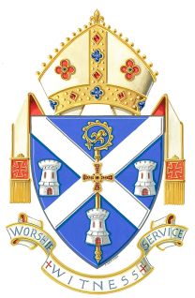
Funeral Arrangements for Rt Rev Kevin J Dunn
at St Mary’s Cathedral, Newcastle upon Tyne

Reception
Bishop Kevin’s body will be received into St Mary’s Cathedral on
Monday 10th March 2008 at 7.00 pm
with the celebration of Mass, followed by a vigil of quiet prayer ending with
Compline at 10.00 pm

This Mass and Vigil of Prayer is open to all people who may wish to attend.
----------

Requiem Mass
Bishop Kevin’s Requiem Mass will be celebrated at St Mary’s Cathedral
on Tuesday 11th March 2008 at 12.00 noon
Burial will follow immediately in the Cathedral Crypt

Unfortunately, due to the seating capacity in St Mary’s Cathedral, it is not possible for this Mass to be open to everyone and therefore entrance is by ticket only. Standing space may be available in the Cathedral precincts and courtyard and loudspeakers will broadcast the Mass outside.
----------

Clergy from other Catholic Dioceses
Any priest wishing to concelebrate at either of the above Masses is asked to contact Bishop’s House on 0191 228 0003 or e-mail office@rcdhn.org.uk by Friday 7th March
----------

Flowers
Donations in lieu of flowers may be given for the Critical Care Unit at the Freeman Hospital. Cheques to be made payable to ‘Bishop Kevin Memorial Fund’ and sent to Bishop’s House, East Denton Hall, 800 West Road, Newcastle upon Tyne, NE5 2BJ
----------
Transport
Please note that car parking is only available in the public car parks throughout Newcastle City Centre. The nearest ones are Times Square Car Park and Grainger Town Multi-Storey. For those travelling by train, Central Station is opposite St Mary’s Cathedral.

