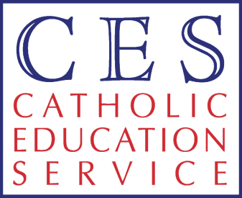

CES Parliamentary Reception - 23 June 2009
Bishop Malcolm McMahon OP, CESEW Chairman

I would like to thank the Secretary of State for his kind remarks regarding Catholic Schools and the very positive relationship between Government and the Catholic Education Service. I also acknowledge the presence of Monsignor Brian from the Apostolic Nunciature. The Holy See like the Government has a continuing and deep interest in education.
Catholic Education has a great deal to offer the world of education. Historically the Catholic community has been pleased that successive governments have enabled the education of Catholic children in a school of choice according the parents’ conscience and of the financial arrangements which meant that it should cost no more for a child to attend a Catholic School than any other state school. Now the time is right for the Catholic community to share what makes them special with the wider community.
‘Catholic ethos’ is an elusive term which defies definition. Catholics know that the ethos in their schools arises from their discipleship of Jesus and its adherence to the Gospel. But the values which support this way of education are, I believe, at the heart of education itself. In valuing our children as being made in God’s image and likeness and as brothers and sisters of Jesus Christ we see education as the process which enables children to discern the truth so that not only do they know the difference between right and wrong but they refine their critical sense to make them people who speak the truth in every aspect of their life. Our children also develop an understanding of life which helps them understand its giftedness. This applies not just to any gifts or talents which an individual may have but that life itself is a gift. This working out of grace in our lives is a journey of discovery which reveals the goodness in each other. This search for goodness is epitomised in the life of St Therese of Lisieux whose relics will be on pilgrimage around our countries in the autumn. The CESEW has prepared a CD for all our schools to help our schools join in this journey towards goodness. Giftedness gives us a basis for the understanding rights and how human rights are to be celebrated in our society. It is these rights based on truth and giftedness which enable our children through the processes of teaching and learning to become free – free to take responsibility as citizens and free from ignorance.
These three principles of Truth, Gift and Freedom are underlying values in our Catholic Schools which we would like to share with others as our society moves towards finding a common morality as a basis for our future.
Malcolm McMahon OP

