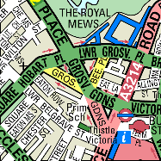 | 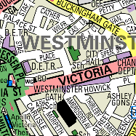
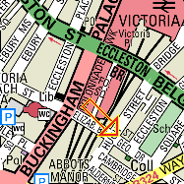 | 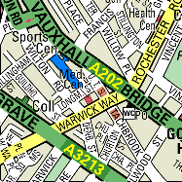

We are here

39 Eccleston Square, London SW1V 1BX
Tel: 020 7630 8220 Fax: 0207 901 4819

From Victoria Station: (A 7-10 minute walk)
Leave via the entrance past platform 1, turn right into Bridge Pl. and walk up to Belgrave Road. Then turn left, walking past the Passport Office and head towards Eccleston Square. Turn right & walk down either side of the Square, CBCEW is located at the far end as indicated above.

