  Rue de Pascale 4  B-1040 Brussels | 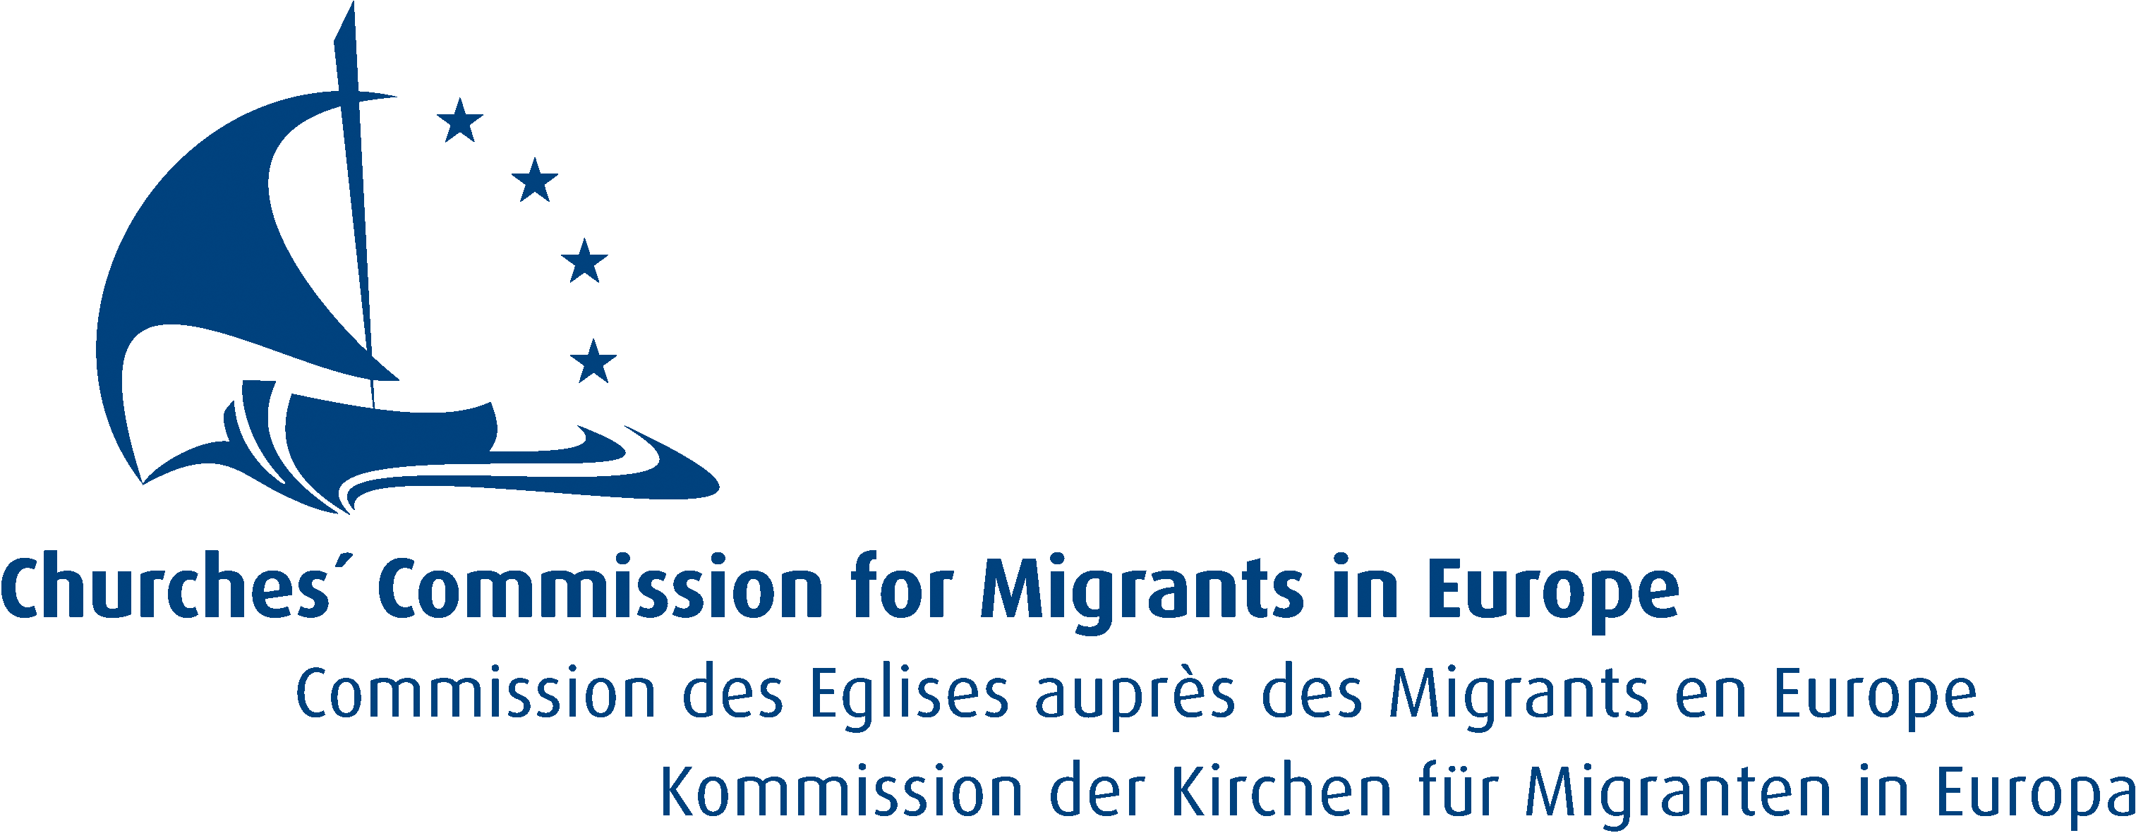  Rue Joseph II 174  B-1000 Brussels
  Commission of the Bishops’ Conferences of the  European Community  - Secretariat -  Rue Stévin 42  B-1000 Brussels | 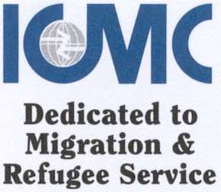  International Catholic Migration Commission  Rue de la Charité 43  B-1210 Brussels
  Jesuit Refugee Service Europe  Haachtsesteenweg 8  B-1210 Brussels |   Quaker Council for European Affairs  Square Ambiorix 50  B-1000 Brussels

Integrating Migrants – Integrating Societies

Essential Elements for EU Migration Policy

Migrants’ Rights Key to Respect and Integration

- On the occasion of International Migrants’ Day 2004, we would like to express our solidarity with the migrants arriving and living in Europe, and to recall our positions on the integration of migrants in Europe.

- Integration requires a holistic approach and is a continuous two way process. In this process, efforts should be expected from migrants to integrate but at the same time efforts are needed from society at large. Migrants’ rights need to be guaranteed. EU and national legislation must recognise that universal human rights apply to migrants.

- The International Convention on the Protection of the Rights of all Migrant Workers and Members of their Families, which entered into force mid-2003, provides a legal framework to protect migrants’ rights. Churches and Christian organisations are convinced that such an international framework is necessary to cope with the challenges of international migration. Therefore, EU Member States and other European countries are called upon to ratify this Convention and adapt their national legislation to these standards. The Economic and Social Committee of the EU and the European Commission have expressed their readiness to pursue ratification of the Convention. We wish to encourage the European Commission and the EU Council to ratify this Convention when the new EU Constitution has been ratified and entered into force.

Integration - a process of change
- Integration of migrants has become a top theme of EU migration policies in the recent period. This is both encouraging and surprising. It is encouraging, because it recognises that migration is a permanent reality throughout Europe; it is surprising because so far integration of migrants falls into policy fields which are the competence of national, regional and local authorities. We wish to express our hope that coordination and exchange with regard to integration policies will improve the quality and understanding of integration as a process for changing societies.

- Successful integration requires skills to access the labour market and material conditions such as adequate housing, as well as opportunities to acquire sufficient linguistic competence. The Commission has outlined how existing schemes at national and EU level, such as the European Employment Strategy, National Action Plans for Social Inclusion, ESF and EQUAL could be used to facilitate integration. With regard to access to the labour market, measures for recognition and assessment of qualifications should be more developed.

- Most of all, integration requires the civic participation of migrants. The recently published European Handbook on Integration by the European Commission promotes that idea. We, however, wish to underline that integration also requires active participation of societies.

- Measures promoting integration should start as early as possible, before or upon arrival, to give migrants, and especially refugees and persons under international protection, the best opportunities to start and enjoy a new life. The more time passes without access to training, employment and social participation, the more difficult it becomes for the person – such dynamics are similar to those for long-term unemployed persons.

- Integration in society works best when family life is facilitated. Thus, protection of family life ought to be a priority for integration policies. To achieve integration, the right to family life of third country nationals needs to be protected. The Council Directive on Family Reunification of 2003, which limits the right of living in family unity falls short of the Member States’ obligation to protect the family. We would urge EU Member States not to use the discretionary possibilities to limit family reunification in the transposition of this directive, as this might harm integration policies as well.

- Inter-cultural exchanges and inter-religious dialogue are important factors for integration which need to be developed. In these dialogues, newcomers and citizens can exchange views on values in community and society, learn from each other, and discover commonalities and differences. For cherishing diversity in society, mediation instruments will have to be developed to prevent or resolve conflicts between communities or between sectors of communities.

- In the current debate about integration, we are concerned that more attention is given to “failed” integration while successful integration is hardly recognised. Most of the examples for failed integration are related to social problems in society, discrimination and racism, e.g. problems in schools for migrant children are dealt with as an integration problem, whereas the social status of the family might be more the reason than the migrant status. Similarly the debate about crimes committed by third country nationals, to which authorities tend to react with special clauses in the law on aliens rather than using the criminal law, thus leading to double penalties for the same crime. Integration would require equality of treatment also for criminals.

- We appreciate the efforts by the European Union since the Thessalonica Summit to promote cooperation and exchange of information in the field of integration. The Annual Report on Migration and Integration of the Commission and the Handbook on Integration are further steps along that way by promoting the exchange of good practices between Member States.

- However, we still repeat our great concern about the tendency among Member States to agree on common standards at the lowest possible level rather than deriving standards from best practice examples. Moreover, civil society, migrants’ associations, NGOs and social organisations should be more involved in the development of policies for integration processes. NGOs, social organisations and authorities should contribute to give more visibility to the multi-cultural realities of European societies by employing migrants at various levels of the organisations and cooperating with associations of migrants.

The signatory organisations represent churches throughout Europe – Anglican, Orthodox, Protestant and Roman Catholic – as well as Christian organisations particularly concerned with migrants and refugees. The history of Christianity is, since its early days, a story of migration and a story of integration of foreigners into new hosting societies. “For I was a stranger, and you welcomed me” (Matt. 25: 35) was therefore the appropriate title for the comment by our organisations on European migration policies. Over centuries through their worldwide community, churches have helped people on the move. In the history of Europe after the Second World War, churches were among the first providing shelter and integration to the millions of refugees and later hosting, informing and integrating migrant workers. As Christian organisations, we are deeply committed to the dignity of the human person, the concept of global solidarity and the promotion of a society welcoming strangers. Integrating migrants will change society, integration is a challenge and a gift. Migration and integration require courage on the side of migrants and, perhaps even more so, on the side of citizens.

18 December 2004

For further details, see: Comments on the Communication from the European Commission on Immigration, Integration & Employment (COM (2003) 336 final)
European Handbook on Integration, European Commission, November 2004, published at the EU Presidency Conference on Integration, Groningen, 9-11 November 2004 http://europa.eu.int/comm/justice_home/doc_centre/immigration/integration/doc/handbook_en.pdf
COM (2004) 508 final

