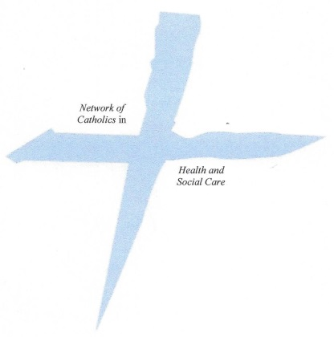
Faith in Health and Social Care Conference
Heythrop College, 23 Kensington Square, London W8 5HN
Saturday 1st November 2014

REGISTRATION FORM
(Please Print)

DELEGATE INFORMATION
FULL NAME (Title, First Name, Surname)
Organisation:
Address:
Post Code: | Email: |  |  | Tel:
Dietary Requirements: Please note below any dietary requirements you may have

payment INFORMATION
I would like to register for the Faith in Health and Social Care Conference 2014
All registrations received will be confirmed by email.
I enclose a cheque (made payable to CaTEW) for £35:00 |  | Yes |  |  | No
(If you wish to apply for help to cover the costs, please contact
Nicholas.Johnson@CBCEW.org.uk)
I wish to pay by bank transfer |  | Yes |  |  | No
A/C Name: CaTEW C/A
Sort Code: 400520
Account No: 81379607
Transaction Ref: Faith in Health and Social Care Conference
Someone else is paying the registration fee and I require an invoice |  | Yes |  |  | No
If you require an invoice, please note below to whom it should be addressed to, including a postal address:

SIGNATURE
Signature |  |  | Date
Please return this form to: Nicholas Johnson, Faith in Health and Social Care Conference 2014
Catholic Trust for England and Wales, 39 Eccleston Square, London SW1V 1BX

