2014- 2015: APPLICATION FORM

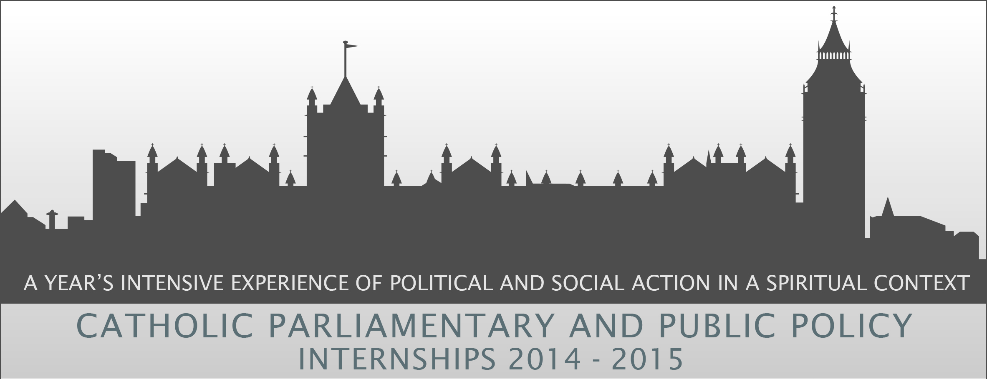
Private and Confidential

Please print clearly in black ink (please use additional sheets if required)
1. Personal Details
Surname:  First Name:  Address:  Postcode:  Tel no: (daytime)  Tel no: (evening)  Mobile: |  | Title:  Marital Status:  University Address (if applicable):  Postcode:  Nationality: (must be a UK resident or have indefinite leave to remain in the UK)  Email:
Please indicate which Internship(s) you are applying for: (number in order of preference)

 | Parliamentary |  |  | Media |  | Public Policy

Candidates can apply for more than one Internship; but if you do you must specify your order of preference (1st, 2nd, 3rd) and complete a supplementary form for each specific internship you have applied for.

2. Secondary and Further / Higher Education
Schools, Colleges and courses attended | Dates From Dates To |  | Details /Qualifications obtained or expected (including professional)

3. Explain why you are applying for our Internship scheme and what you would bring to it?

4. Explain how you feel you would benefit from participating in the scheme?

5. What aspects of your experience best demonstrate your commitment to the Catholic faith and to social and political engagement?

6. Why do you think Christians should be involved in politics or public policy?

7. References:

Please provide two referees, one of whom should be your Parish Priest or University Chaplain and the other your most recent employer (paid/voluntary) or course tutor. Please note that it is your responsibility to ensure that your referees send your references directly to us before Wednesday 26th February, otherwise your application cannot be considered for shortlisting.

Present or most recent employer/course tutor

Name and Position:

Organisation Address:

Postcode:
Tel No. | Fax
Parish Priest or University Chaplain

Name and Position:

Address:

Postcode:
Tel No. | Fax
8. Declaration:

I confirm that the information given in this application is, to the best of my knowledge, true and complete. I acknowledge that any false statement or material omission may be sufficient cause for my application being rejected or my internship terminated.

Signed: | Date:
Closing Date for completed Application Forms: 5pm on Wednesday 26th February 2014
Either email the completed application to interns@cbcew.org.uk or post it to: Michaela Kelly, Head of HR, 39 Eccleston Square, London. SW1V 1BX

9. How did you hear about the CPI Scheme?

Catholic Trust for England and Wales Registered Charity No. 1097482

Supplementary Form 1
Parliamentary (Christian MP or Bishops Parliamentary office)

Please explain why you are interested in the Parliamentary Internship and how you would benefit from participating in this specific internship.

Describe how your previous experience, knowledge, skills and training will help you to succeed in this Internship.

Supplementary Form 2
Public Policy (CAFOD or CSAN)

Please explain why you are interested in the Public Policy Internship and how you would benefit from participating in this specific internship.

Describe how your previous experience, knowledge, skills and training will help you to succeed in this Internship.

Supplementary Form
Media (Archbishops House)

Please explain why you are interested in the Media Internship and how you would benefit from participating in this specific internship.

Describe how your previous experience, knowledge, skills and training will help you to succeed in this Internship.

